Metanalysis of performance in condition of Stereotype Boost (stBoost)

Geiser C. Challco [geiser@alumni.usp.br](mailto:geiser@alumni.usp.br)

Table of Contents

## Initial Variables and Loading Data

cond <- "stBoost"  
to_remove <- c('S11')  
sub.groups <- c("country","age","ed.level","intervention",  
 "country:age","country:ed.level","country:intervention",  
 "age:intervention","ed.level:intervention",  
 "country:age:intervention","country:ed.level:intervention")

dat <- read_excel("../data/data-without-outliers.xlsx", sheet = "perform-cond-descriptive")  
dat <- dat[!dat$study %in% to_remove, ]  
  
leg <- read_excel("../data/data-without-outliers.xlsx", sheet = "legend")

## New names:  
## • `` -> `...10`

leg <- leg[!leg$study %in% to_remove, ]  
  
idx.e <- which(dat$condition==cond)  
idx.c <- which(dat$condition=="control")  
  
data <- data.frame(  
 study = dat$study[idx.c],  
 n.e = dat$N[idx.e], mean.e = dat$M[idx.e], sd.e = dat$SD[idx.e],  
 n.c = dat$N[idx.c], mean.c = dat$M[idx.c], sd.c = dat$SD[idx.c]  
)  
for (cgroups in strsplit(sub.groups,":")) {  
 data[[paste0(cgroups, collapse = ":")]] <- sapply(data$study, FUN = function(x) {  
 paste0(sapply(cgroups, FUN = function(namecol) leg[[namecol]][which(x == leg$study)]), collapse = ":")  
 })  
}  
data[["lbl"]] <- sapply(data$study, FUN = function(x) leg$Note[which(x == leg$study)])

## Perform meta-analyses

m.cont <- metacont(  
 n.e = n.e, mean.e = mean.e, sd.e = sd.e, n.c = n.c, mean.c = mean.c, sd.c = sd.c,  
 studlab = lbl, data = data, sm = "SMD", method.smd = "Hedges",  
 fixed = F, random = T, method.tau = "REML", hakn = T, title = paste("Performance in",cond)  
)  
summary(m.cont)

## Review: Performance in stBoost  
##   
## SMD 95%-CI %W(random)  
## S1 0.0615 [-0.4388; 0.5618] 8.4  
## S2 -0.1670 [-0.6440; 0.3101] 9.2  
## S3 -0.2975 [-0.8356; 0.2405] 7.2  
## S4 0.3656 [-0.1862; 0.9173] 6.9  
## S5 -0.0315 [-0.4473; 0.3843] 12.1  
## S6 0.2023 [-0.2451; 0.6496] 10.5  
## S7 0.2952 [-0.1052; 0.6957] 13.1  
## S8: Conducted by BNU -0.1339 [-0.6179; 0.3501] 9.0  
## S9: Albuquerque, et al. (2017) 0.3264 [-0.0970; 0.7498] 11.7  
## S10: Only use prompt msgs 0.2641 [-0.1544; 0.6827] 12.0  
##   
## Number of studies combined: k = 10  
## Number of observations: o = 748  
##   
## SMD 95%-CI t p-value  
## Random effects model 0.1071 [-0.0532; 0.2675] 1.51 0.1649  
##   
## Quantifying heterogeneity:  
## tau^2 = 0 [0.0000; 0.1227]; tau = 0 [0.0000; 0.3502]  
## I^2 = 0.0% [0.0%; 62.4%]; H = 1.00 [1.00; 1.63]  
##   
## Test of heterogeneity:  
## Q d.f. p-value  
## 8.29 9 0.5055  
##   
## Details on meta-analytical method:  
## - Inverse variance method  
## - Restricted maximum-likelihood estimator for tau^2  
## - Q-profile method for confidence interval of tau^2 and tau  
## - Hartung-Knapp adjustment for random effects model  
## - Hedges' g (bias corrected standardised mean difference; using exact formulae)

forest(m.cont, digits=2, digits.sd = 2, test.overall = T, label.e = cond)

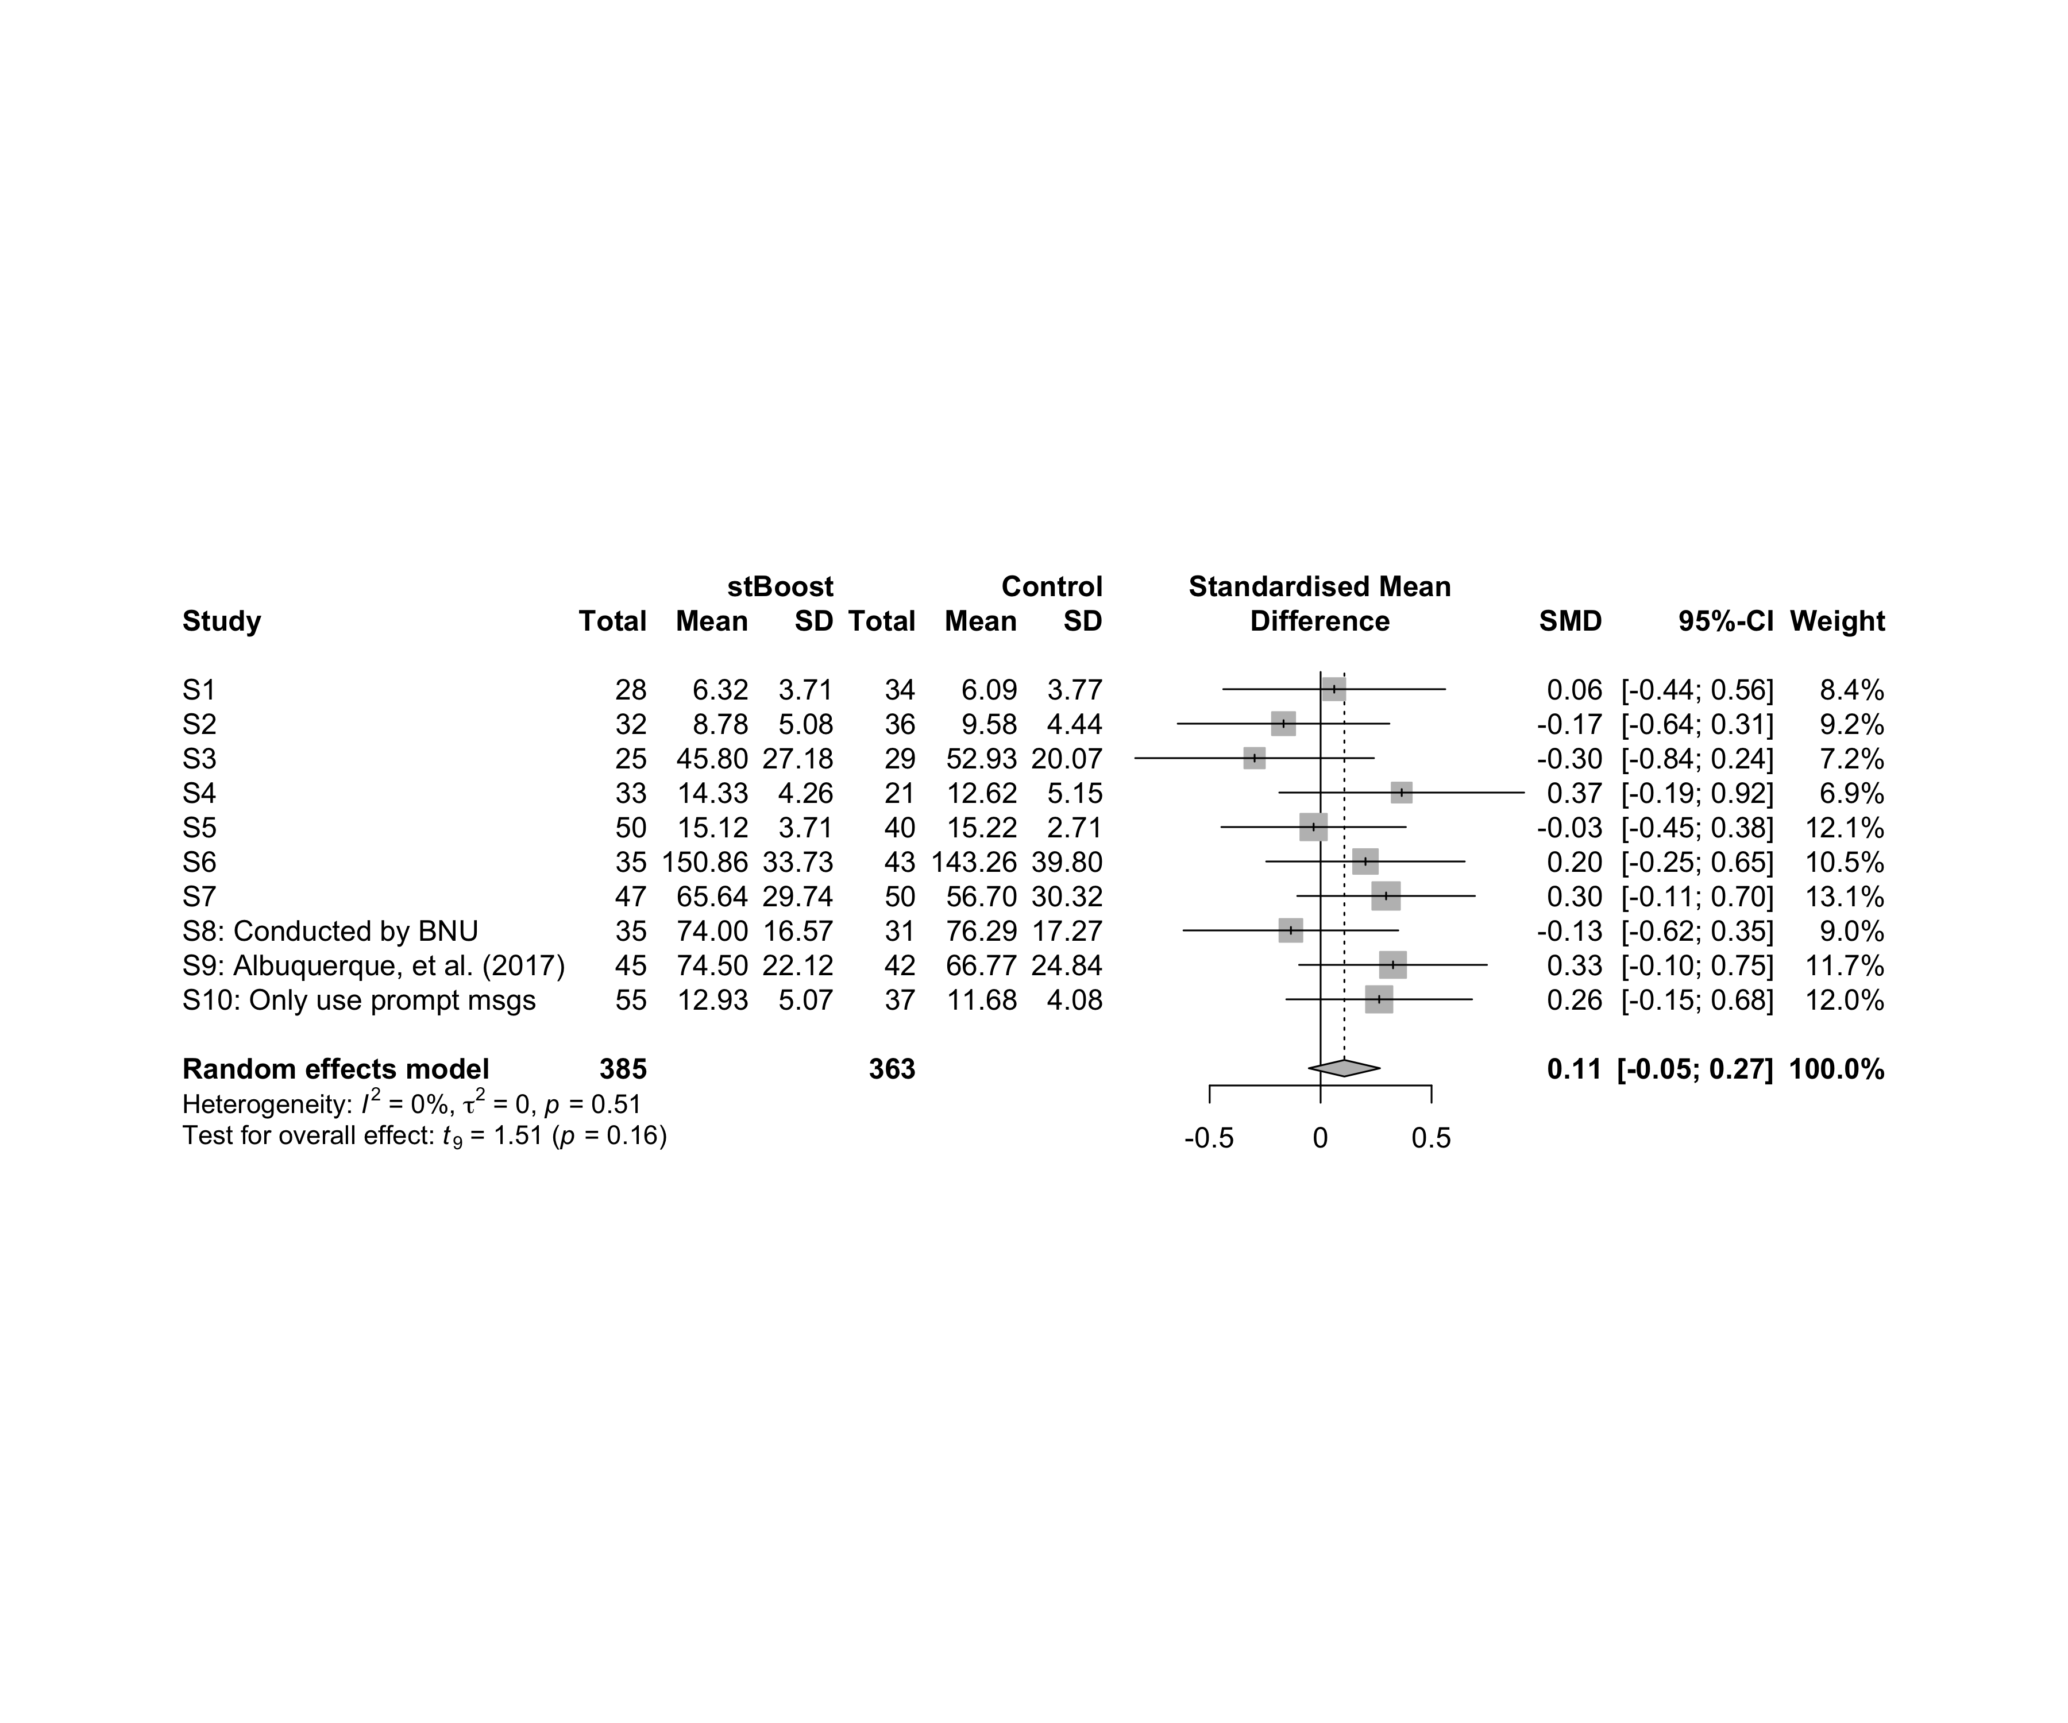

### Subgroup analysis by “country”

m.sg4sub <- update.meta(m.cont, subgroup = country, random = T, fixed = F)  
summary(m.sg4sub)

## Review: Performance in stBoost  
##   
## SMD 95%-CI %W(random) country  
## S1 0.0615 [-0.4388; 0.5618] 8.4 Brazil  
## S2 -0.1670 [-0.6440; 0.3101] 9.2 Brazil  
## S3 -0.2975 [-0.8356; 0.2405] 7.2 Brazil  
## S4 0.3656 [-0.1862; 0.9173] 6.9 Brazil  
## S5 -0.0315 [-0.4473; 0.3843] 12.1 Brazil  
## S6 0.2023 [-0.2451; 0.6496] 10.5 Brazil  
## S7 0.2952 [-0.1052; 0.6957] 13.1 Brazil  
## S8: Conducted by BNU -0.1339 [-0.6179; 0.3501] 9.0 China  
## S9: Albuquerque, et al. (2017) 0.3264 [-0.0970; 0.7498] 11.7 Brazil  
## S10: Only use prompt msgs 0.2641 [-0.1544; 0.6827] 12.0 Brazil  
##   
## Number of studies combined: k = 10  
## Number of observations: o = 748  
##   
## SMD 95%-CI t p-value  
## Random effects model 0.1071 [-0.0532; 0.2675] 1.51 0.1649  
##   
## Quantifying heterogeneity:  
## tau^2 = 0 [0.0000; 0.1227]; tau = 0 [0.0000; 0.3502]  
## I^2 = 0.0% [0.0%; 62.4%]; H = 1.00 [1.00; 1.63]  
##   
## Test of heterogeneity:  
## Q d.f. p-value  
## 8.29 9 0.5055  
##   
## Results for subgroups (random effects model):  
## k SMD 95%-CI tau^2 tau Q I^2  
## country = Brazil 9 0.1308 [-0.0390; 0.3007] 0 0 7.24 0.0%  
## country = China 1 -0.1339 [-0.6179; 0.3501] -- -- 0.00 --  
##   
## Test for subgroup differences (random effects model):  
## Q d.f. p-value  
## Between groups 1.06 1 0.3042  
##   
## Details on meta-analytical method:  
## - Inverse variance method  
## - Restricted maximum-likelihood estimator for tau^2  
## - Q-profile method for confidence interval of tau^2 and tau  
## - Hartung-Knapp adjustment for random effects model  
## - Hedges' g (bias corrected standardised mean difference; using exact formulae)

forest(m.sg4sub, digits=2, digits.sd = 2, test.overall = T, label.e = cond)

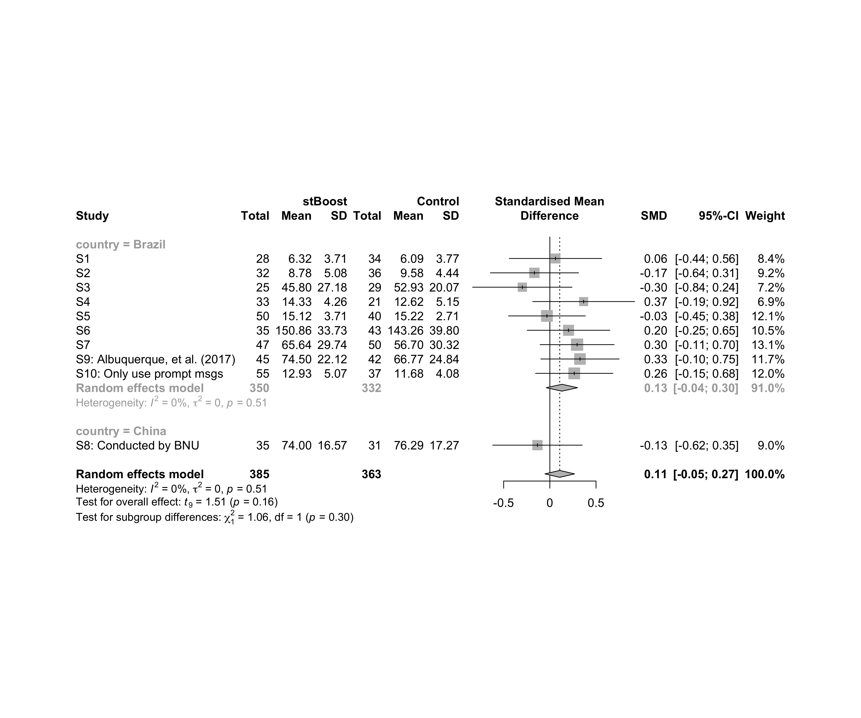

### Subgroup analysis by “age”

m.sg4sub <- update.meta(m.cont, subgroup = country, random = T, fixed = F)  
summary(m.sg4sub)

## Review: Performance in stBoost  
##   
## SMD 95%-CI %W(random) country  
## S1 0.0615 [-0.4388; 0.5618] 8.4 Brazil  
## S2 -0.1670 [-0.6440; 0.3101] 9.2 Brazil  
## S3 -0.2975 [-0.8356; 0.2405] 7.2 Brazil  
## S4 0.3656 [-0.1862; 0.9173] 6.9 Brazil  
## S5 -0.0315 [-0.4473; 0.3843] 12.1 Brazil  
## S6 0.2023 [-0.2451; 0.6496] 10.5 Brazil  
## S7 0.2952 [-0.1052; 0.6957] 13.1 Brazil  
## S8: Conducted by BNU -0.1339 [-0.6179; 0.3501] 9.0 China  
## S9: Albuquerque, et al. (2017) 0.3264 [-0.0970; 0.7498] 11.7 Brazil  
## S10: Only use prompt msgs 0.2641 [-0.1544; 0.6827] 12.0 Brazil  
##   
## Number of studies combined: k = 10  
## Number of observations: o = 748  
##   
## SMD 95%-CI t p-value  
## Random effects model 0.1071 [-0.0532; 0.2675] 1.51 0.1649  
##   
## Quantifying heterogeneity:  
## tau^2 = 0 [0.0000; 0.1227]; tau = 0 [0.0000; 0.3502]  
## I^2 = 0.0% [0.0%; 62.4%]; H = 1.00 [1.00; 1.63]  
##   
## Test of heterogeneity:  
## Q d.f. p-value  
## 8.29 9 0.5055  
##   
## Results for subgroups (random effects model):  
## k SMD 95%-CI tau^2 tau Q I^2  
## country = Brazil 9 0.1308 [-0.0390; 0.3007] 0 0 7.24 0.0%  
## country = China 1 -0.1339 [-0.6179; 0.3501] -- -- 0.00 --  
##   
## Test for subgroup differences (random effects model):  
## Q d.f. p-value  
## Between groups 1.06 1 0.3042  
##   
## Details on meta-analytical method:  
## - Inverse variance method  
## - Restricted maximum-likelihood estimator for tau^2  
## - Q-profile method for confidence interval of tau^2 and tau  
## - Hartung-Knapp adjustment for random effects model  
## - Hedges' g (bias corrected standardised mean difference; using exact formulae)

forest(m.sg4sub, digits=2, digits.sd = 2, test.overall = T, label.e = cond)



### Subgroup analysis by “ed.level”

m.sg4sub <- update.meta(m.cont, subgroup = ed.level, random = T, fixed = F)  
summary(m.sg4sub)

## Review: Performance in stBoost  
##   
## SMD 95%-CI %W(random) ed.level  
## S1 0.0615 [-0.4388; 0.5618] 8.4 upper-secundary  
## S2 -0.1670 [-0.6440; 0.3101] 9.2 upper-secundary  
## S3 -0.2975 [-0.8356; 0.2405] 7.2 upper-secundary  
## S4 0.3656 [-0.1862; 0.9173] 6.9 higher-education  
## S5 -0.0315 [-0.4473; 0.3843] 12.1 higher-education  
## S6 0.2023 [-0.2451; 0.6496] 10.5 higher-education  
## S7 0.2952 [-0.1052; 0.6957] 13.1 unknown  
## S8: Conducted by BNU -0.1339 [-0.6179; 0.3501] 9.0 unknown  
## S9: Albuquerque, et al. (2017) 0.3264 [-0.0970; 0.7498] 11.7 unknown  
## S10: Only use prompt msgs 0.2641 [-0.1544; 0.6827] 12.0 upper-secundary  
##   
## Number of studies combined: k = 10  
## Number of observations: o = 748  
##   
## SMD 95%-CI t p-value  
## Random effects model 0.1071 [-0.0532; 0.2675] 1.51 0.1649  
##   
## Quantifying heterogeneity:  
## tau^2 = 0 [0.0000; 0.1227]; tau = 0 [0.0000; 0.3502]  
## I^2 = 0.0% [0.0%; 62.4%]; H = 1.00 [1.00; 1.63]  
##   
## Test of heterogeneity:  
## Q d.f. p-value  
## 8.29 9 0.5055  
##   
## Results for subgroups (random effects model):  
## k SMD 95%-CI tau^2 tau Q I^2  
## ed.level = upper-secundary 4 -0.0049 [-0.4065; 0.3967] 0.0082 0.0905 3.23 7.2%  
## ed.level = higher-education 3 0.1443 [-0.3400; 0.6285] 0 0 1.37 0.0%  
## ed.level = unknown 3 0.1903 [-0.4104; 0.7910] 0.0036 0.0599 2.38 16.1%  
##   
## Test for subgroup differences (random effects model):  
## Q d.f. p-value  
## Between groups 1.25 2 0.5347  
##   
## Details on meta-analytical method:  
## - Inverse variance method  
## - Restricted maximum-likelihood estimator for tau^2  
## - Q-profile method for confidence interval of tau^2 and tau  
## - Hartung-Knapp adjustment for random effects model  
## - Hedges' g (bias corrected standardised mean difference; using exact formulae)

forest(m.sg4sub, digits=2, digits.sd = 2, test.overall = T, label.e = cond)

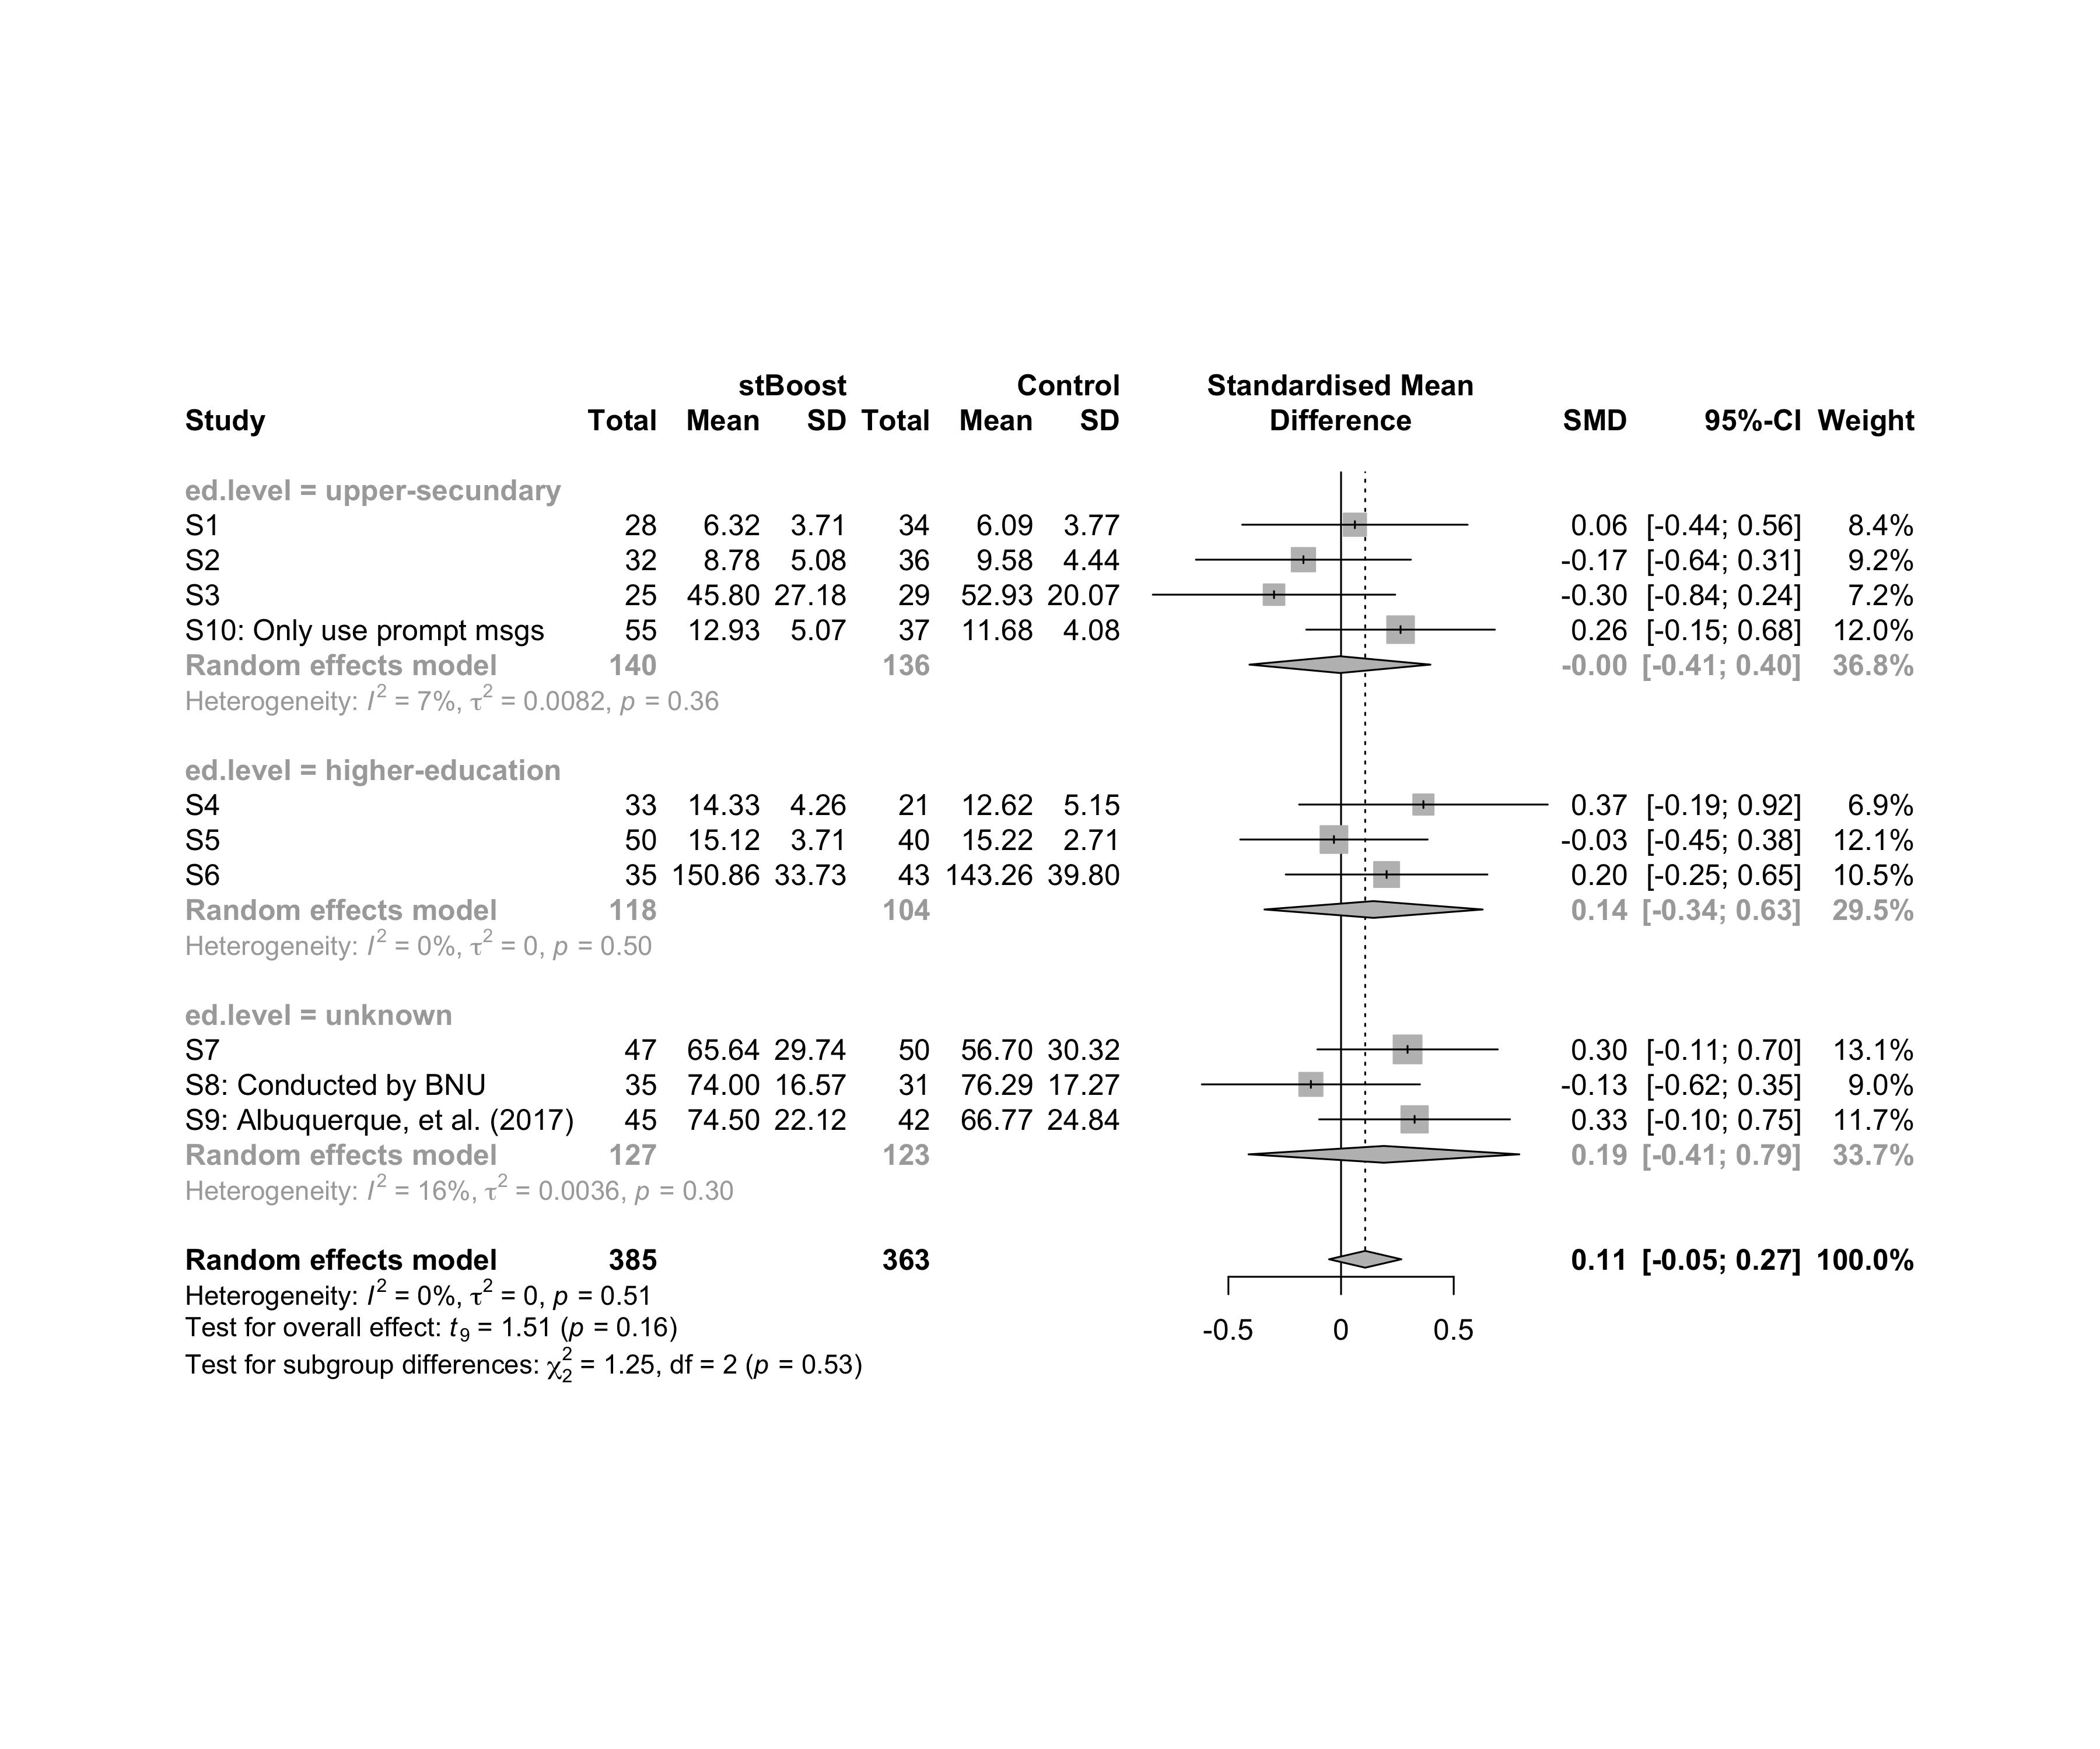

### Subgroup analysis by “intervention”

m.sg4sub <- update.meta(m.cont, subgroup = `intervention`, random = T, fixed = F)  
summary(m.sg4sub)

## Review: Performance in stBoost  
##   
## SMD 95%-CI %W(random)  
## S1 0.0615 [-0.4388; 0.5618] 8.4  
## S2 -0.1670 [-0.6440; 0.3101] 9.2  
## S3 -0.2975 [-0.8356; 0.2405] 7.2  
## S4 0.3656 [-0.1862; 0.9173] 6.9  
## S5 -0.0315 [-0.4473; 0.3843] 12.1  
## S6 0.2023 [-0.2451; 0.6496] 10.5  
## S7 0.2952 [-0.1052; 0.6957] 13.1  
## S8: Conducted by BNU -0.1339 [-0.6179; 0.3501] 9.0  
## S9: Albuquerque, et al. (2017) 0.3264 [-0.0970; 0.7498] 11.7  
## S10: Only use prompt msgs 0.2641 [-0.1544; 0.6827] 12.0  
## intervention  
## S1 Gender-stereotype color, ranking, badges, and avatar  
## S2 Gender-stereotype color, ranking, badges, and avatar  
## S3 Gender-stereotype color, ranking, badges, and avatar  
## S4 Gender-stereotype color, ranking, badges, and avatar  
## S5 Gender-stereotype color, ranking, badges, and avatar  
## S6 Gender-stereotype color, ranking, badges, and avatar  
## S7 Gender-stereotype color, ranking, badges, and avatar  
## S8: Conducted by BNU Gender-stereotype color, ranking, badges, and avatar  
## S9: Albuquerque, et al. (2017) Gender-stereotype color, ranking, badges, and avatar  
## S10: Only use prompt msgs Gender-stereotyped motivational message prompts  
##   
## Number of studies combined: k = 10  
## Number of observations: o = 748  
##   
## SMD 95%-CI t p-value  
## Random effects model 0.1071 [-0.0532; 0.2675] 1.51 0.1649  
##   
## Quantifying heterogeneity:  
## tau^2 = 0 [0.0000; 0.1227]; tau = 0 [0.0000; 0.3502]  
## I^2 = 0.0% [0.0%; 62.4%]; H = 1.00 [1.00; 1.63]  
##   
## Test of heterogeneity:  
## Q d.f. p-value  
## 8.29 9 0.5055  
##   
## Results for subgroups (random effects model):  
## k SMD 95%-CI tau^2 tau Q I^2  
## intervention = Gender-stereotype color, rankin ... 9 0.0858 [-0.0920; 0.2636] 0 0 7.67 0.0%  
## intervention = Gender-stereotyped motivational ... 1 0.2641 [-0.1544; 0.6827] -- -- 0.00 --  
##   
## Test for subgroup differences (random effects model):  
## Q d.f. p-value  
## Between groups 0.62 1 0.4323  
##   
## Details on meta-analytical method:  
## - Inverse variance method  
## - Restricted maximum-likelihood estimator for tau^2  
## - Q-profile method for confidence interval of tau^2 and tau  
## - Hartung-Knapp adjustment for random effects model  
## - Hedges' g (bias corrected standardised mean difference; using exact formulae)

forest(m.sg4sub, digits=2, digits.sd = 2, test.overall = T, label.e = cond)

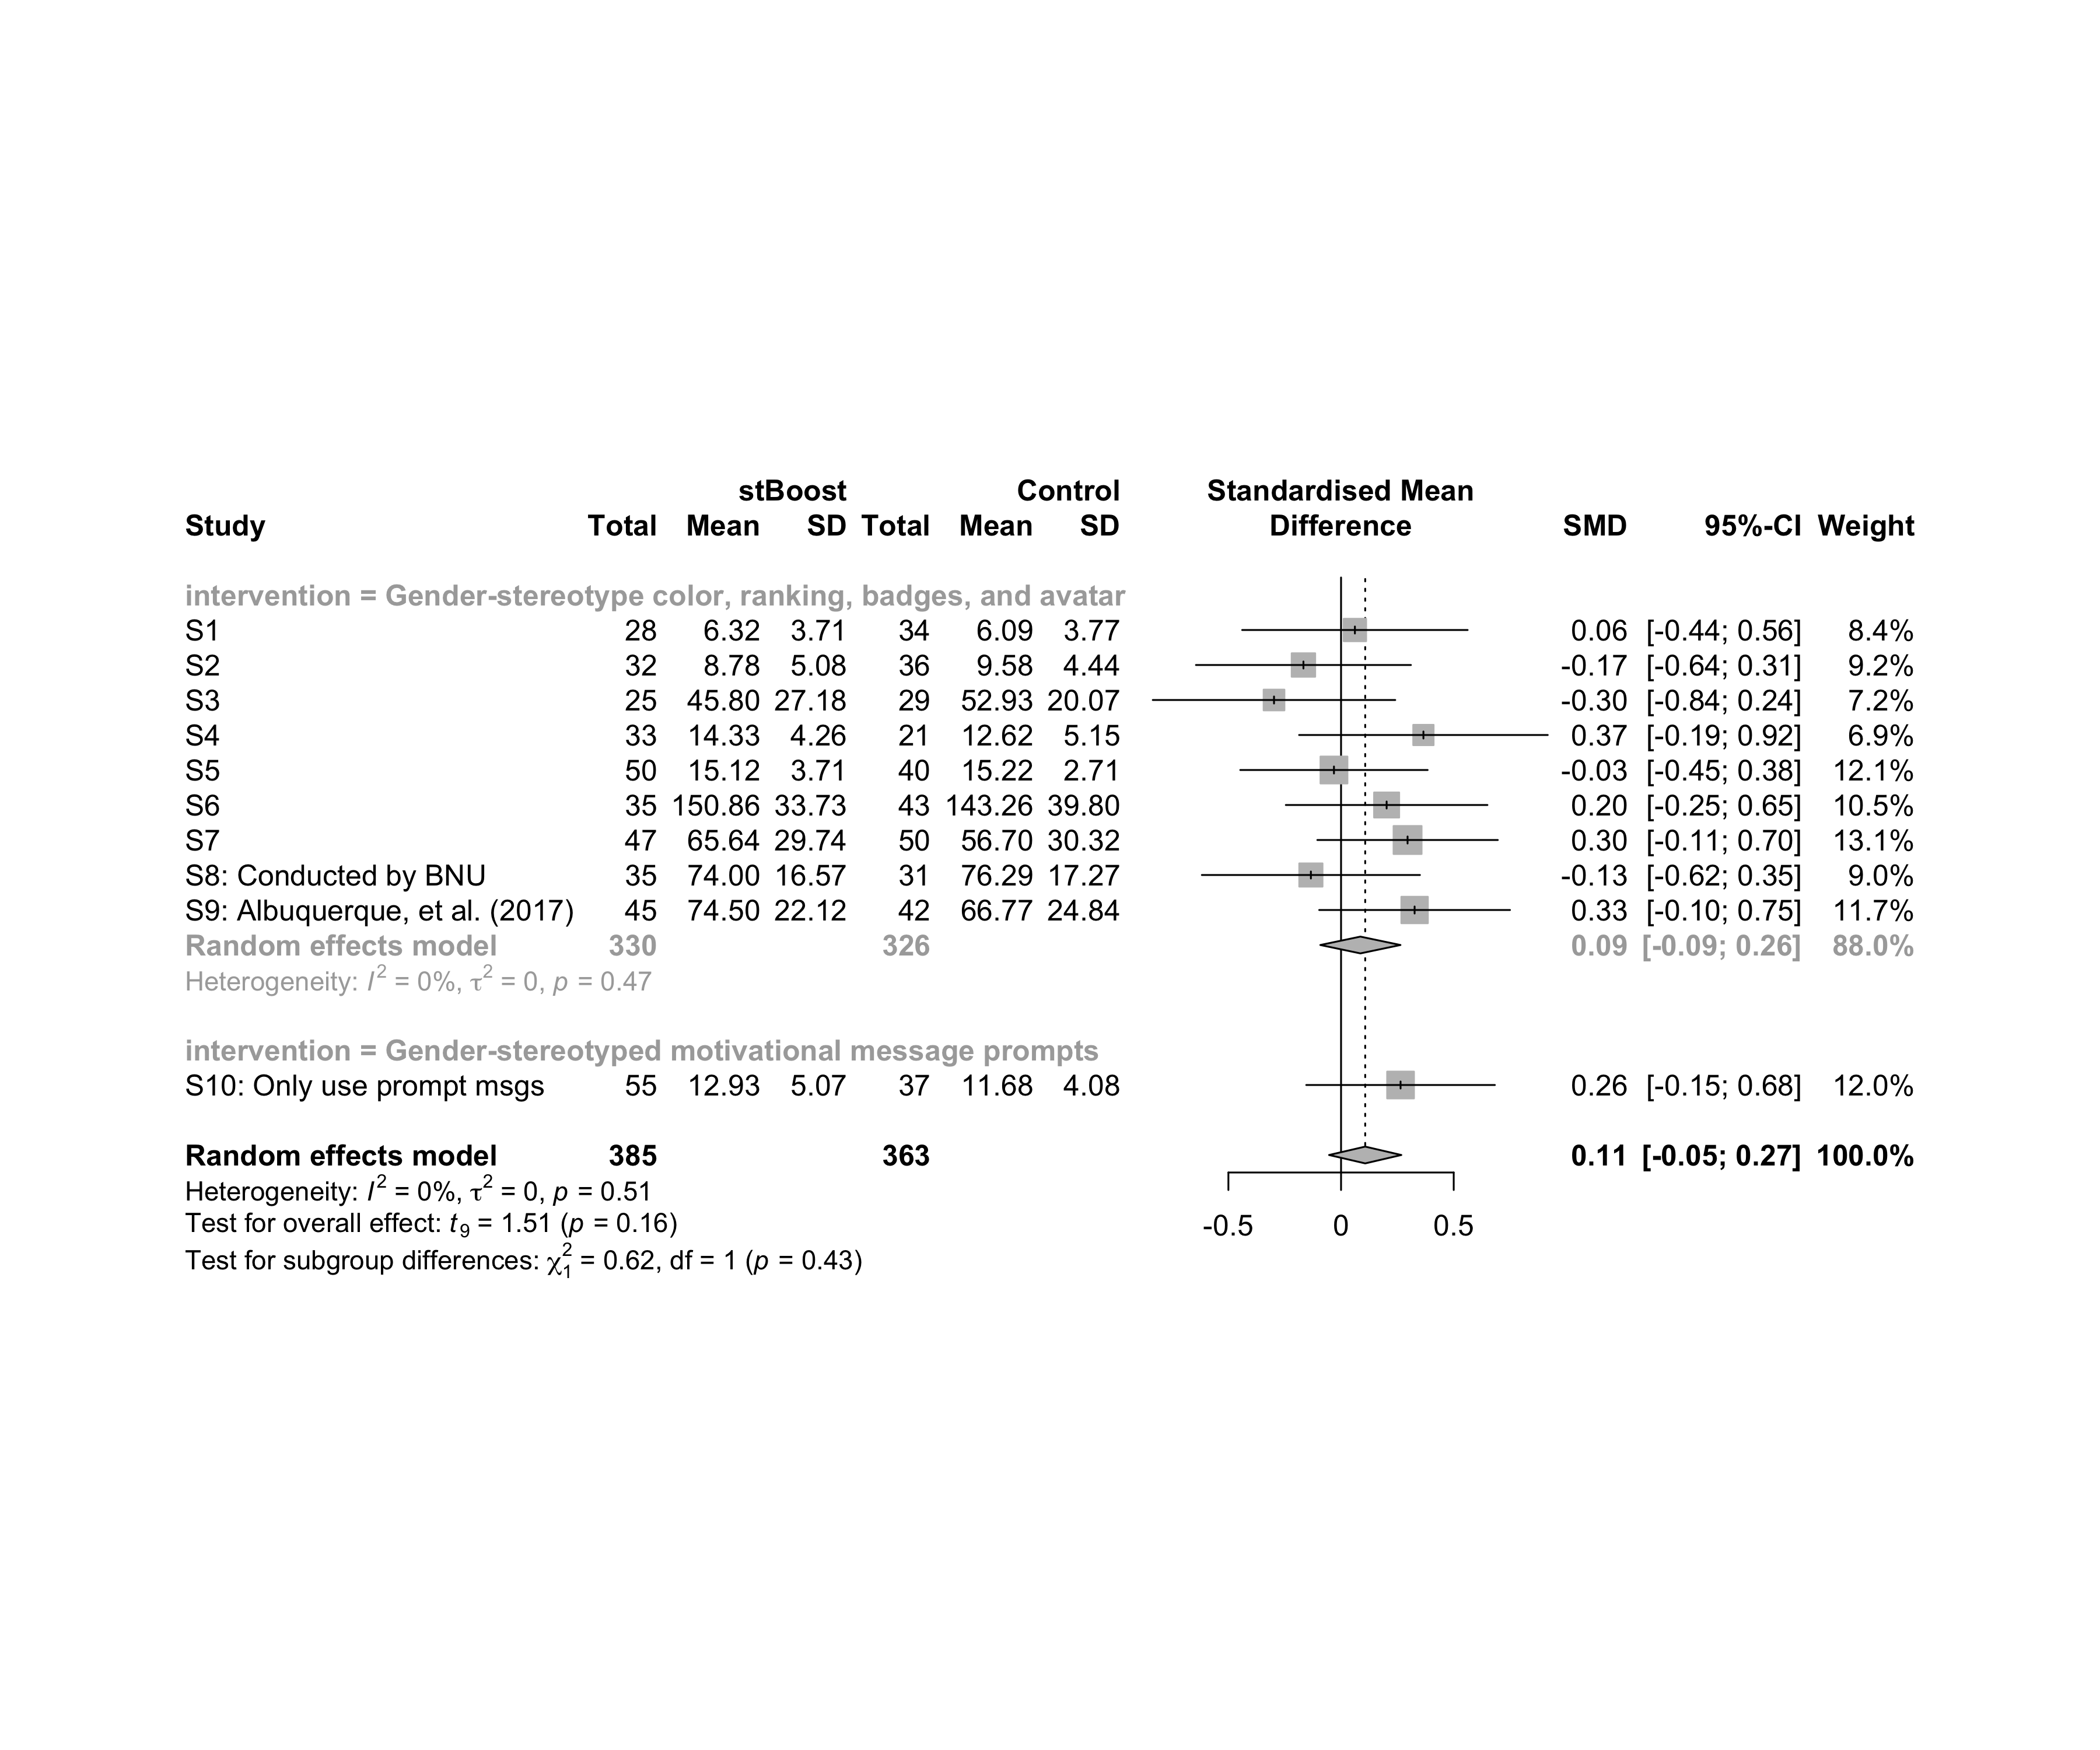

### Subgroup analysis by “country:age”

m.sg4sub <- update.meta(m.cont, subgroup = `country:age`, random = T, fixed = F)  
summary(m.sg4sub)

## Review: Performance in stBoost  
##   
## SMD 95%-CI %W(random) country:age  
## S1 0.0615 [-0.4388; 0.5618] 8.4 Brazil:adolescent  
## S2 -0.1670 [-0.6440; 0.3101] 9.2 Brazil:adolescent  
## S3 -0.2975 [-0.8356; 0.2405] 7.2 Brazil:adolescent  
## S4 0.3656 [-0.1862; 0.9173] 6.9 Brazil:adult  
## S5 -0.0315 [-0.4473; 0.3843] 12.1 Brazil:adult  
## S6 0.2023 [-0.2451; 0.6496] 10.5 Brazil:adult  
## S7 0.2952 [-0.1052; 0.6957] 13.1 Brazil:adult  
## S8: Conducted by BNU -0.1339 [-0.6179; 0.3501] 9.0 China:no-restriction  
## S9: Albuquerque, et al. (2017) 0.3264 [-0.0970; 0.7498] 11.7 Brazil:no-restriction  
## S10: Only use prompt msgs 0.2641 [-0.1544; 0.6827] 12.0 Brazil:adolescence  
##   
## Number of studies combined: k = 10  
## Number of observations: o = 748  
##   
## SMD 95%-CI t p-value  
## Random effects model 0.1071 [-0.0532; 0.2675] 1.51 0.1649  
##   
## Quantifying heterogeneity:  
## tau^2 = 0 [0.0000; 0.1227]; tau = 0 [0.0000; 0.3502]  
## I^2 = 0.0% [0.0%; 62.4%]; H = 1.00 [1.00; 1.63]  
##   
## Test of heterogeneity:  
## Q d.f. p-value  
## 8.29 9 0.5055  
##   
## Results for subgroups (random effects model):  
## k SMD 95%-CI tau^2 tau Q I^2  
## country:age = Brazil:adolescent 3 -0.1280 [-0.5695; 0.3135] 0 0 0.96 0.0%  
## country:age = Brazil:adult 4 0.1906 [-0.0844; 0.4656] 0 0 1.75 0.0%  
## country:age = China:no-restriction 1 -0.1339 [-0.6179; 0.3501] -- -- 0.00 --  
## country:age = Brazil:no-restriction 1 0.3264 [-0.0970; 0.7498] -- -- 0.00 --  
## country:age = Brazil:adolescence 1 0.2641 [-0.1544; 0.6827] -- -- 0.00 --  
##   
## Test for subgroup differences (random effects model):  
## Q d.f. p-value  
## Between groups 8.54 4 0.0737  
##   
## Details on meta-analytical method:  
## - Inverse variance method  
## - Restricted maximum-likelihood estimator for tau^2  
## - Q-profile method for confidence interval of tau^2 and tau  
## - Hartung-Knapp adjustment for random effects model  
## - Hedges' g (bias corrected standardised mean difference; using exact formulae)

forest(m.sg4sub, digits=2, digits.sd = 2, test.overall = T, label.e = cond)

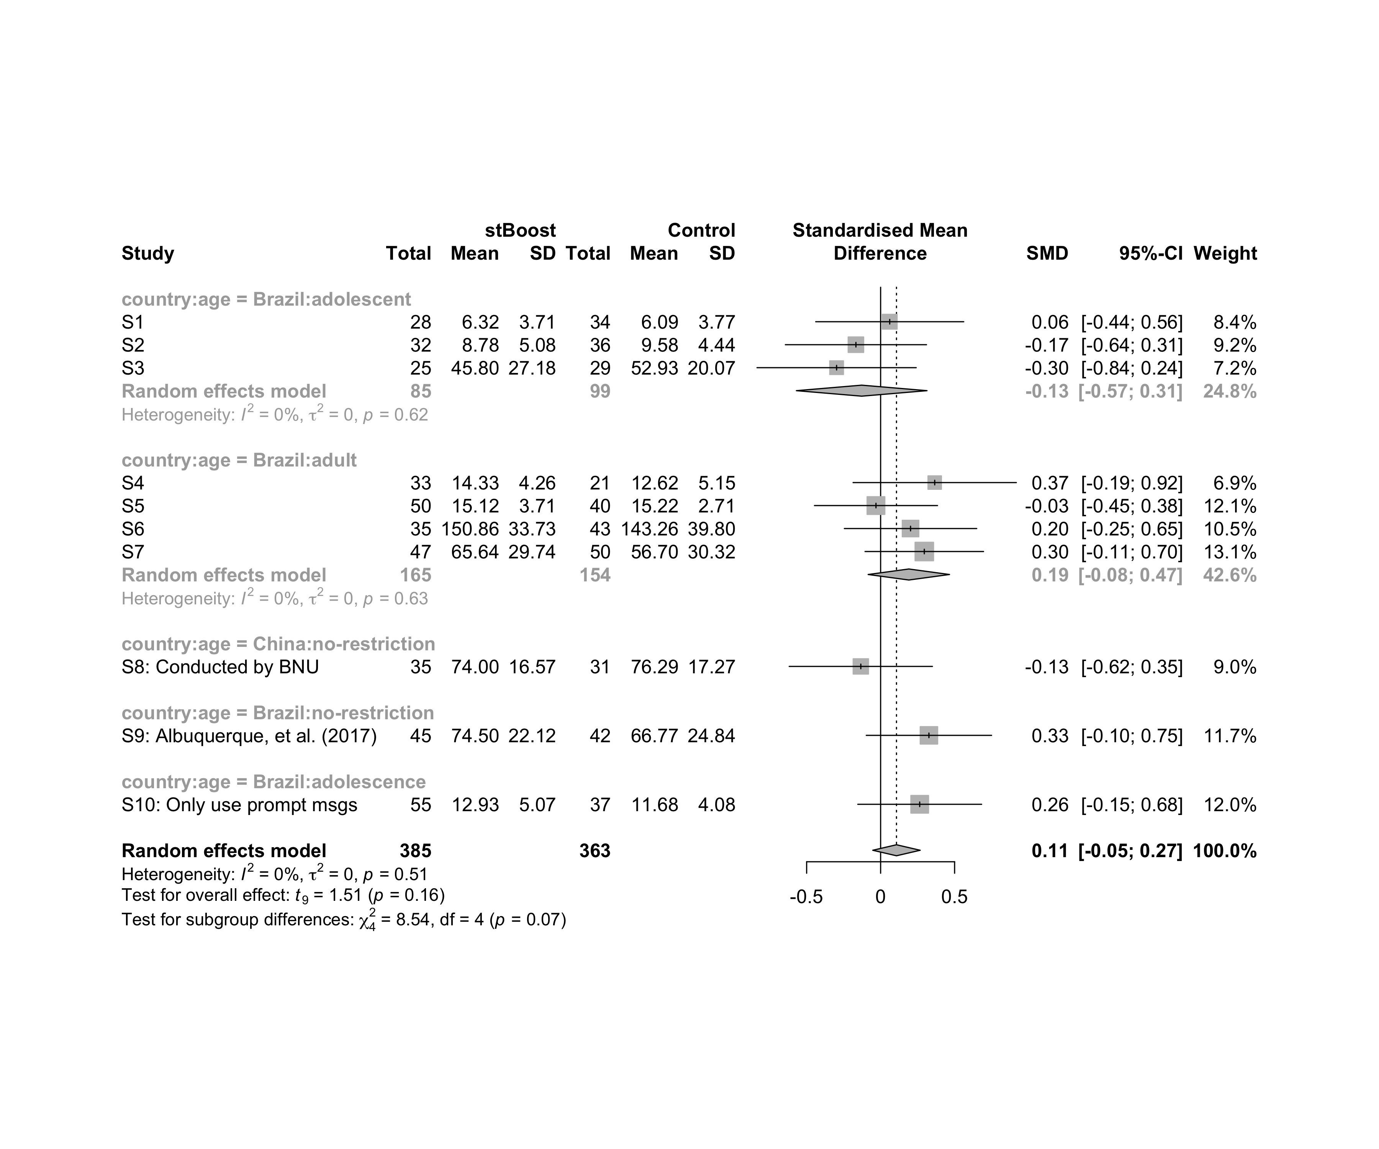

### Subgroup analysis by “country:ed.level”

m.sg4sub <- update.meta(m.cont, subgroup = `country:ed.level`, random = T, fixed = F)  
summary(m.sg4sub)

## Review: Performance in stBoost  
##   
## SMD 95%-CI %W(random) country:ed.level  
## S1 0.0615 [-0.4388; 0.5618] 8.4 Brazil:upper-secundary  
## S2 -0.1670 [-0.6440; 0.3101] 9.2 Brazil:upper-secundary  
## S3 -0.2975 [-0.8356; 0.2405] 7.2 Brazil:upper-secundary  
## S4 0.3656 [-0.1862; 0.9173] 6.9 Brazil:higher-education  
## S5 -0.0315 [-0.4473; 0.3843] 12.1 Brazil:higher-education  
## S6 0.2023 [-0.2451; 0.6496] 10.5 Brazil:higher-education  
## S7 0.2952 [-0.1052; 0.6957] 13.1 Brazil:unknown  
## S8: Conducted by BNU -0.1339 [-0.6179; 0.3501] 9.0 China:unknown  
## S9: Albuquerque, et al. (2017) 0.3264 [-0.0970; 0.7498] 11.7 Brazil:unknown  
## S10: Only use prompt msgs 0.2641 [-0.1544; 0.6827] 12.0 Brazil:upper-secundary  
##   
## Number of studies combined: k = 10  
## Number of observations: o = 748  
##   
## SMD 95%-CI t p-value  
## Random effects model 0.1071 [-0.0532; 0.2675] 1.51 0.1649  
##   
## Quantifying heterogeneity:  
## tau^2 = 0 [0.0000; 0.1227]; tau = 0 [0.0000; 0.3502]  
## I^2 = 0.0% [0.0%; 62.4%]; H = 1.00 [1.00; 1.63]  
##   
## Test of heterogeneity:  
## Q d.f. p-value  
## 8.29 9 0.5055  
##   
## Results for subgroups (random effects model):  
## k SMD 95%-CI tau^2 tau Q I^2  
## country:ed.level = Brazil:upper-secundary 4 -0.0049 [-0.4065; 0.3967] 0.0082 0.0905 3.23 7.2%  
## country:ed.level = Brazil:higher-education 3 0.1443 [-0.3400; 0.6285] 0 0 1.37 0.0%  
## country:ed.level = Brazil:unknown 2 0.3099 [ 0.1119; 0.5080] 0 0 0.01 0.0%  
## country:ed.level = China:unknown 1 -0.1339 [-0.6179; 0.3501] -- -- 0.00 --  
##   
## Test for subgroup differences (random effects model):  
## Q d.f. p-value  
## Between groups 11.25 3 0.0105  
##   
## Details on meta-analytical method:  
## - Inverse variance method  
## - Restricted maximum-likelihood estimator for tau^2  
## - Q-profile method for confidence interval of tau^2 and tau  
## - Hartung-Knapp adjustment for random effects model  
## - Hedges' g (bias corrected standardised mean difference; using exact formulae)

forest(m.sg4sub, digits=2, digits.sd = 2, test.overall = T, label.e = cond)

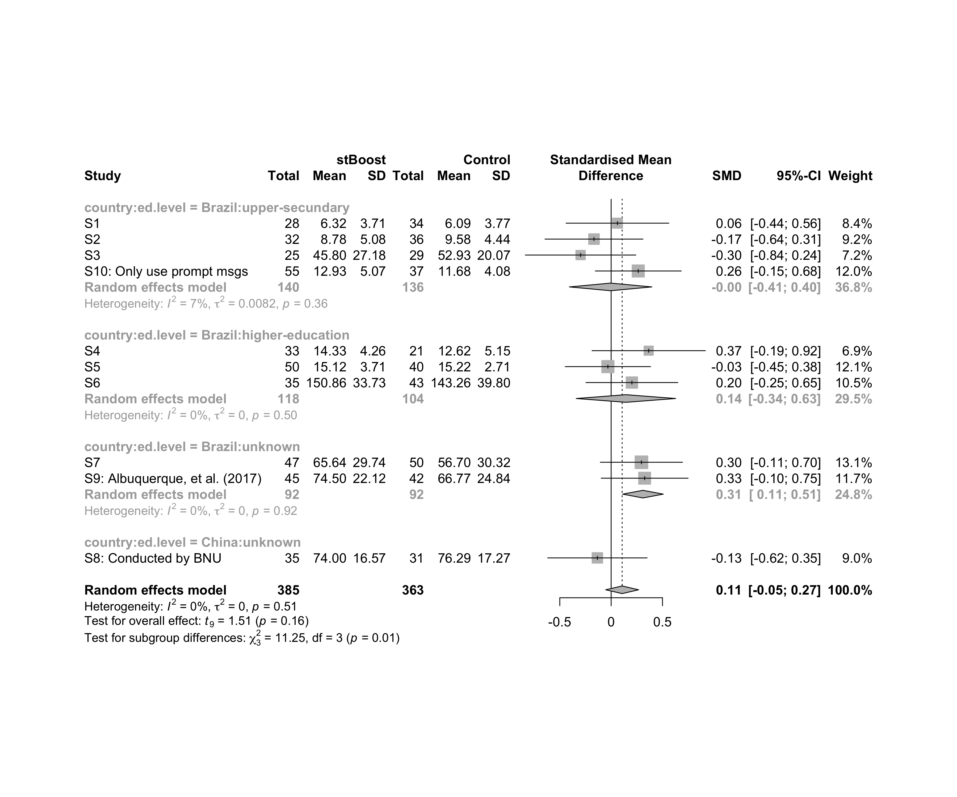

### Subgroup analysis by “country:intervention”

m.sg4sub <- update.meta(m.cont, subgroup = `country:intervention`, random = T, fixed = F)  
summary(m.sg4sub)

## Review: Performance in stBoost  
##   
## SMD 95%-CI %W(random)  
## S1 0.0615 [-0.4388; 0.5618] 8.4  
## S2 -0.1670 [-0.6440; 0.3101] 9.2  
## S3 -0.2975 [-0.8356; 0.2405] 7.2  
## S4 0.3656 [-0.1862; 0.9173] 6.9  
## S5 -0.0315 [-0.4473; 0.3843] 12.1  
## S6 0.2023 [-0.2451; 0.6496] 10.5  
## S7 0.2952 [-0.1052; 0.6957] 13.1  
## S8: Conducted by BNU -0.1339 [-0.6179; 0.3501] 9.0  
## S9: Albuquerque, et al. (2017) 0.3264 [-0.0970; 0.7498] 11.7  
## S10: Only use prompt msgs 0.2641 [-0.1544; 0.6827] 12.0  
## country:intervention  
## S1 Brazil:Gender-stereotype color, ranking, badges, and avatar  
## S2 Brazil:Gender-stereotype color, ranking, badges, and avatar  
## S3 Brazil:Gender-stereotype color, ranking, badges, and avatar  
## S4 Brazil:Gender-stereotype color, ranking, badges, and avatar  
## S5 Brazil:Gender-stereotype color, ranking, badges, and avatar  
## S6 Brazil:Gender-stereotype color, ranking, badges, and avatar  
## S7 Brazil:Gender-stereotype color, ranking, badges, and avatar  
## S8: Conducted by BNU China:Gender-stereotype color, ranking, badges, and avatar  
## S9: Albuquerque, et al. (2017) Brazil:Gender-stereotype color, ranking, badges, and avatar  
## S10: Only use prompt msgs Brazil:Gender-stereotyped motivational message prompts  
##   
## Number of studies combined: k = 10  
## Number of observations: o = 748  
##   
## SMD 95%-CI t p-value  
## Random effects model 0.1071 [-0.0532; 0.2675] 1.51 0.1649  
##   
## Quantifying heterogeneity:  
## tau^2 = 0 [0.0000; 0.1227]; tau = 0 [0.0000; 0.3502]  
## I^2 = 0.0% [0.0%; 62.4%]; H = 1.00 [1.00; 1.63]  
##   
## Test of heterogeneity:  
## Q d.f. p-value  
## 8.29 9 0.5055  
##   
## Results for subgroups (random effects model):  
## k SMD 95%-CI tau^2 tau Q  
## country:intervention = Brazil:Gender-stereotype color, ... 8 0.1107 [-0.0828; 0.3042] <0.0001 0.0002 6.79  
## country:intervention = China:Gender-stereotype color, ... 1 -0.1339 [-0.6179; 0.3501] -- -- 0.00  
## country:intervention = Brazil:Gender-stereotyped motiv ... 1 0.2641 [-0.1544; 0.6827] -- -- 0.00  
## I^2  
## country:intervention = Brazil:Gender-stereotype color, ... 0.0%  
## country:intervention = China:Gender-stereotype color, ... --  
## country:intervention = Brazil:Gender-stereotyped motiv ... --  
##   
## Test for subgroup differences (random effects model):  
## Q d.f. p-value  
## Between groups 1.49 2 0.4736  
##   
## Details on meta-analytical method:  
## - Inverse variance method  
## - Restricted maximum-likelihood estimator for tau^2  
## - Q-profile method for confidence interval of tau^2 and tau  
## - Hartung-Knapp adjustment for random effects model  
## - Hedges' g (bias corrected standardised mean difference; using exact formulae)

forest(m.sg4sub, digits=2, digits.sd = 2, test.overall = T, label.e = cond)

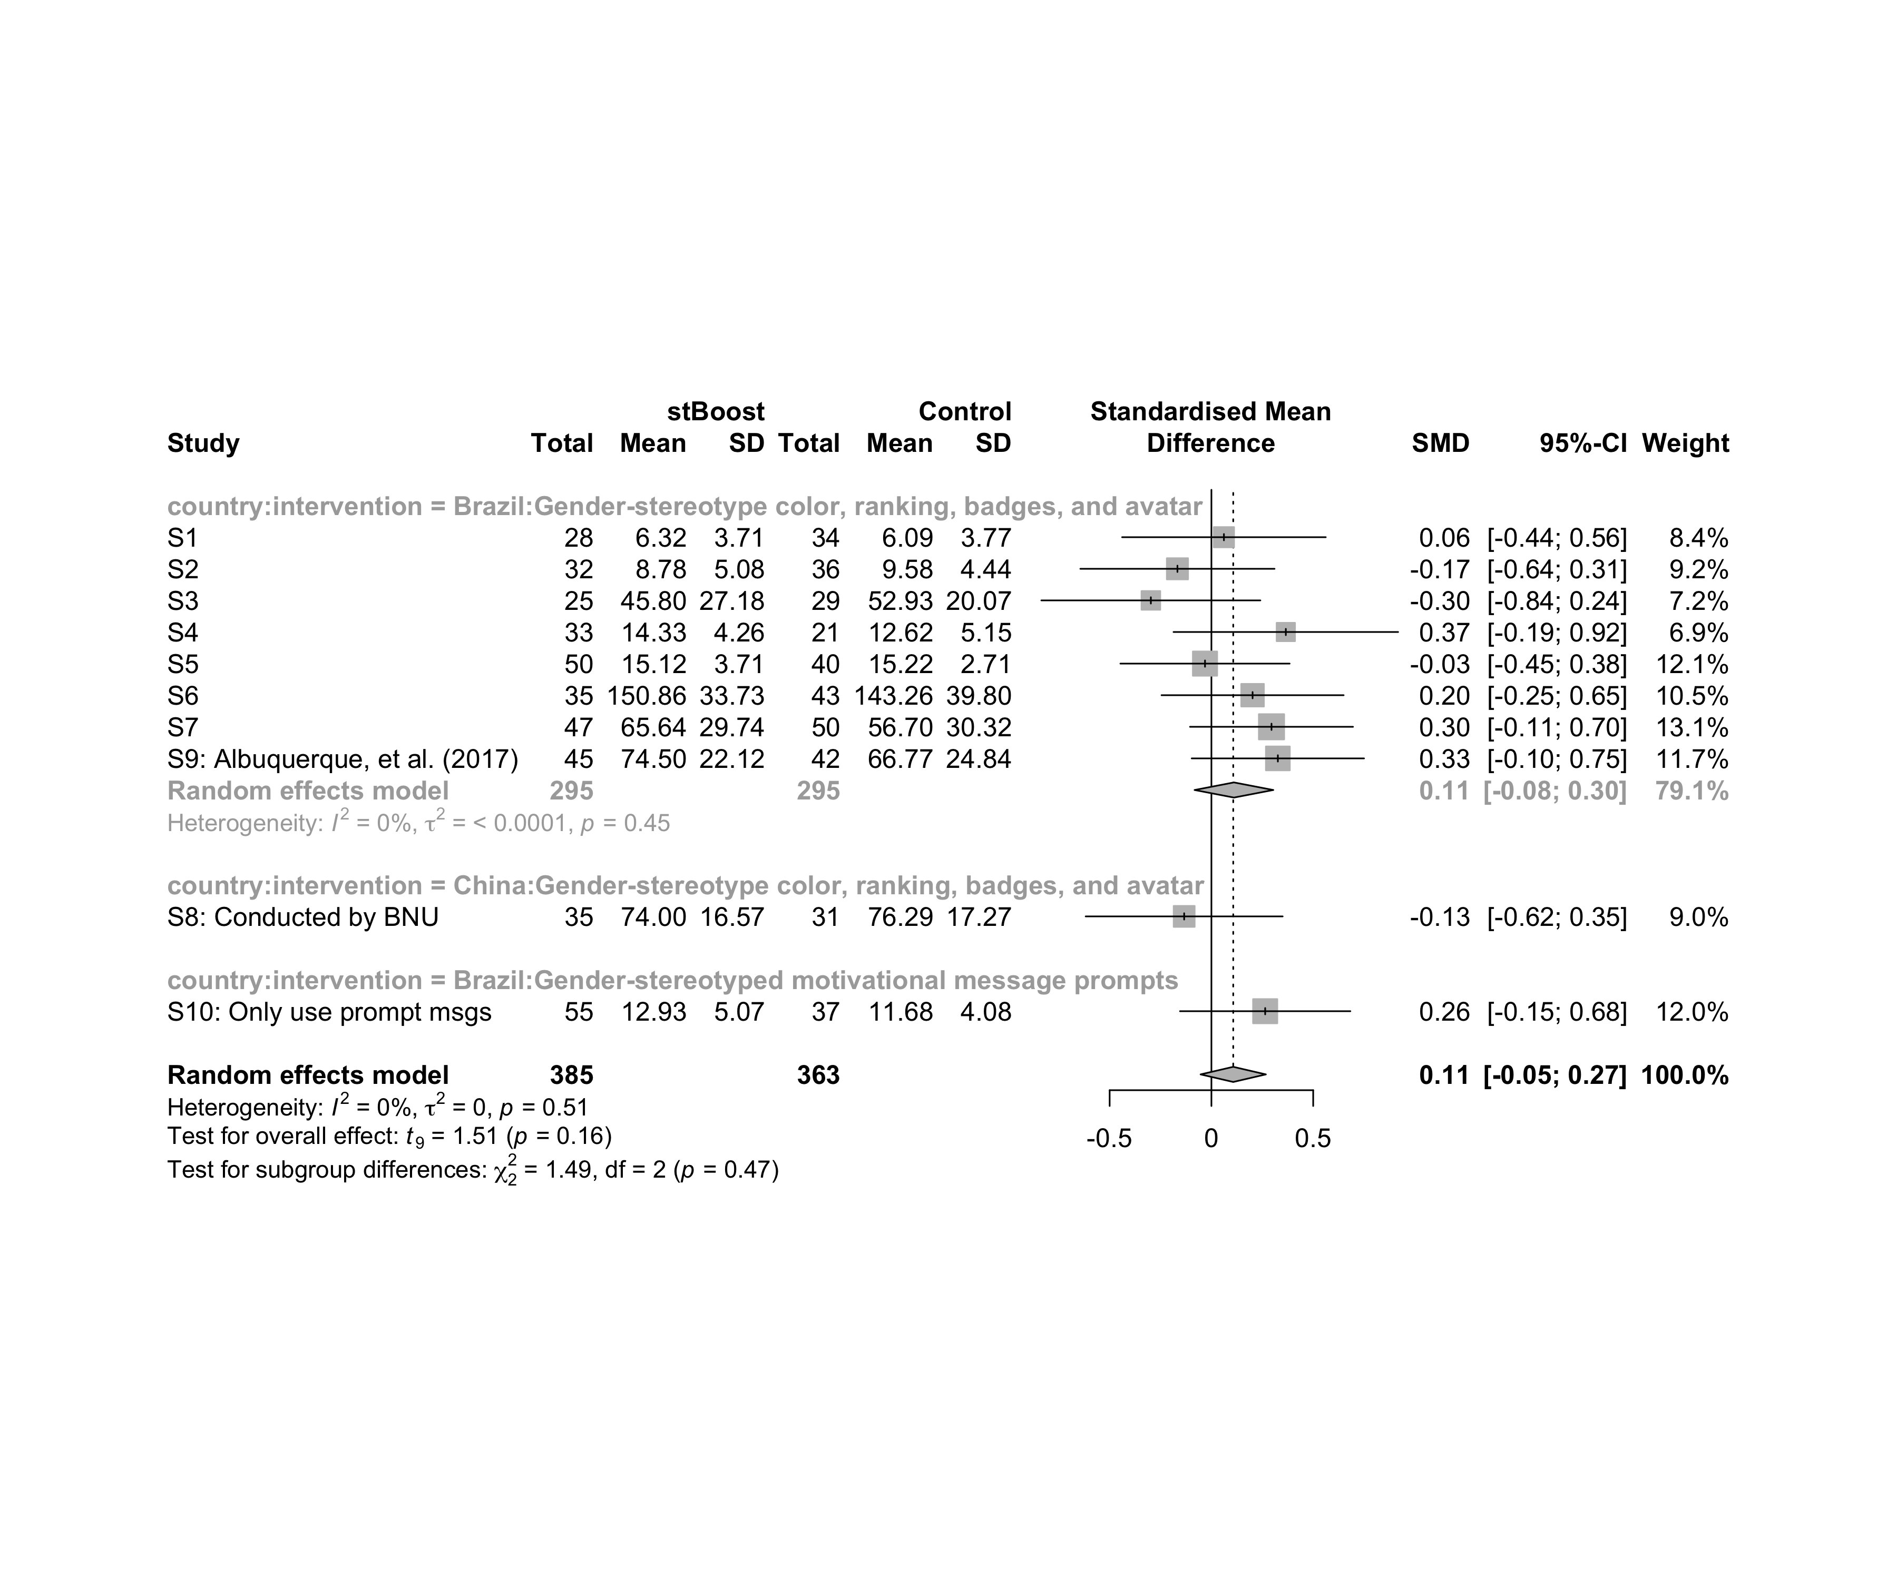

### Subgroup analysis by “age:intervention”

m.sg4sub <- update.meta(m.cont, subgroup = `age:intervention`, random = T, fixed = F)  
summary(m.sg4sub)

## Review: Performance in stBoost  
##   
## SMD 95%-CI %W(random)  
## S1 0.0615 [-0.4388; 0.5618] 8.4  
## S2 -0.1670 [-0.6440; 0.3101] 9.2  
## S3 -0.2975 [-0.8356; 0.2405] 7.2  
## S4 0.3656 [-0.1862; 0.9173] 6.9  
## S5 -0.0315 [-0.4473; 0.3843] 12.1  
## S6 0.2023 [-0.2451; 0.6496] 10.5  
## S7 0.2952 [-0.1052; 0.6957] 13.1  
## S8: Conducted by BNU -0.1339 [-0.6179; 0.3501] 9.0  
## S9: Albuquerque, et al. (2017) 0.3264 [-0.0970; 0.7498] 11.7  
## S10: Only use prompt msgs 0.2641 [-0.1544; 0.6827] 12.0  
## age:intervention  
## S1 adolescent:Gender-stereotype color, ranking, badges, and avatar  
## S2 adolescent:Gender-stereotype color, ranking, badges, and avatar  
## S3 adolescent:Gender-stereotype color, ranking, badges, and avatar  
## S4 adult:Gender-stereotype color, ranking, badges, and avatar  
## S5 adult:Gender-stereotype color, ranking, badges, and avatar  
## S6 adult:Gender-stereotype color, ranking, badges, and avatar  
## S7 adult:Gender-stereotype color, ranking, badges, and avatar  
## S8: Conducted by BNU no-restriction:Gender-stereotype color, ranking, badges, and avatar  
## S9: Albuquerque, et al. (2017) no-restriction:Gender-stereotype color, ranking, badges, and avatar  
## S10: Only use prompt msgs adolescence:Gender-stereotyped motivational message prompts  
##   
## Number of studies combined: k = 10  
## Number of observations: o = 748  
##   
## SMD 95%-CI t p-value  
## Random effects model 0.1071 [-0.0532; 0.2675] 1.51 0.1649  
##   
## Quantifying heterogeneity:  
## tau^2 = 0 [0.0000; 0.1227]; tau = 0 [0.0000; 0.3502]  
## I^2 = 0.0% [0.0%; 62.4%]; H = 1.00 [1.00; 1.63]  
##   
## Test of heterogeneity:  
## Q d.f. p-value  
## 8.29 9 0.5055  
##   
## Results for subgroups (random effects model):  
## k SMD 95%-CI tau^2 tau Q  
## age:intervention = adolescent:Gender-stereotype co ... 3 -0.1280 [-0.5695; 0.3135] 0 0 0.96  
## age:intervention = adult:Gender-stereotype color, ... 4 0.1906 [-0.0844; 0.4656] 0 0 1.75  
## age:intervention = no-restriction:Gender-stereotyp ... 2 0.1118 [-2.8060; 3.0296] 0.0521 0.2283 1.97  
## age:intervention = adolescence:Gender-stereotyped ... 1 0.2641 [-0.1544; 0.6827] -- -- 0.00  
## I^2  
## age:intervention = adolescent:Gender-stereotype co ... 0.0%  
## age:intervention = adult:Gender-stereotype color, ... 0.0%  
## age:intervention = no-restriction:Gender-stereotyp ... 49.2%  
## age:intervention = adolescence:Gender-stereotyped ... --  
##   
## Test for subgroup differences (random effects model):  
## Q d.f. p-value  
## Between groups 6.51 3 0.0892  
##   
## Details on meta-analytical method:  
## - Inverse variance method  
## - Restricted maximum-likelihood estimator for tau^2  
## - Q-profile method for confidence interval of tau^2 and tau  
## - Hartung-Knapp adjustment for random effects model  
## - Hedges' g (bias corrected standardised mean difference; using exact formulae)

forest(m.sg4sub, digits=2, digits.sd = 2, test.overall = T, label.e = cond)

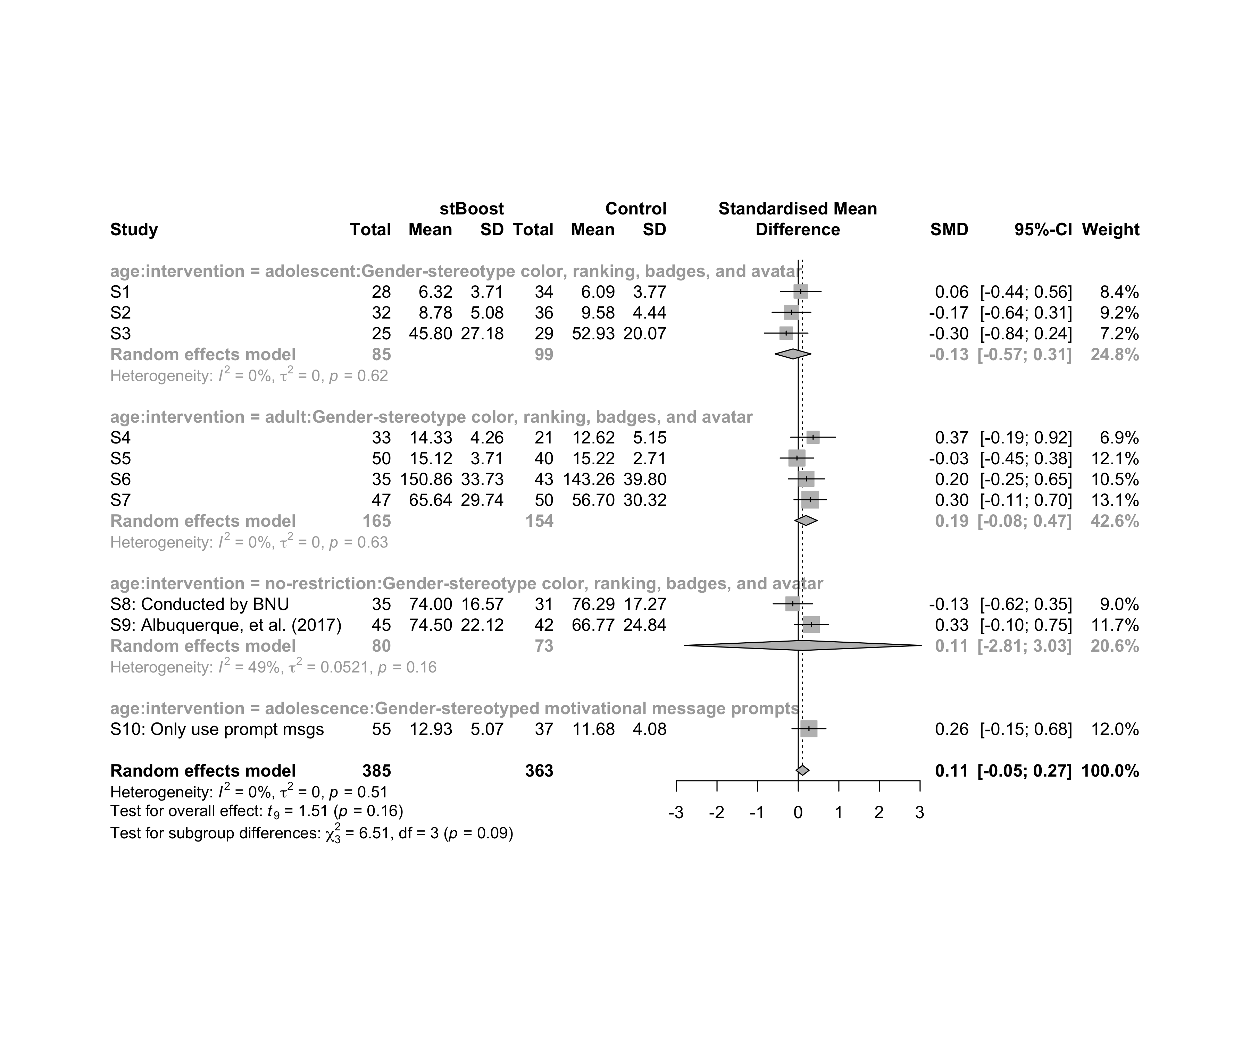

### Subgroup analysis by “ed.level:intervention”

m.sg4sub <- update.meta(m.cont, subgroup = `ed.level:intervention`, random = T, fixed = F)  
summary(m.sg4sub)

## Review: Performance in stBoost  
##   
## SMD 95%-CI %W(random)  
## S1 0.0615 [-0.4388; 0.5618] 8.4  
## S2 -0.1670 [-0.6440; 0.3101] 9.2  
## S3 -0.2975 [-0.8356; 0.2405] 7.2  
## S4 0.3656 [-0.1862; 0.9173] 6.9  
## S5 -0.0315 [-0.4473; 0.3843] 12.1  
## S6 0.2023 [-0.2451; 0.6496] 10.5  
## S7 0.2952 [-0.1052; 0.6957] 13.1  
## S8: Conducted by BNU -0.1339 [-0.6179; 0.3501] 9.0  
## S9: Albuquerque, et al. (2017) 0.3264 [-0.0970; 0.7498] 11.7  
## S10: Only use prompt msgs 0.2641 [-0.1544; 0.6827] 12.0  
## ed.level:intervention  
## S1 upper-secundary:Gender-stereotype color, ranking, badges, and avatar  
## S2 upper-secundary:Gender-stereotype color, ranking, badges, and avatar  
## S3 upper-secundary:Gender-stereotype color, ranking, badges, and avatar  
## S4 higher-education:Gender-stereotype color, ranking, badges, and avatar  
## S5 higher-education:Gender-stereotype color, ranking, badges, and avatar  
## S6 higher-education:Gender-stereotype color, ranking, badges, and avatar  
## S7 unknown:Gender-stereotype color, ranking, badges, and avatar  
## S8: Conducted by BNU unknown:Gender-stereotype color, ranking, badges, and avatar  
## S9: Albuquerque, et al. (2017) unknown:Gender-stereotype color, ranking, badges, and avatar  
## S10: Only use prompt msgs upper-secundary:Gender-stereotyped motivational message prompts  
##   
## Number of studies combined: k = 10  
## Number of observations: o = 748  
##   
## SMD 95%-CI t p-value  
## Random effects model 0.1071 [-0.0532; 0.2675] 1.51 0.1649  
##   
## Quantifying heterogeneity:  
## tau^2 = 0 [0.0000; 0.1227]; tau = 0 [0.0000; 0.3502]  
## I^2 = 0.0% [0.0%; 62.4%]; H = 1.00 [1.00; 1.63]  
##   
## Test of heterogeneity:  
## Q d.f. p-value  
## 8.29 9 0.5055  
##   
## Results for subgroups (random effects model):  
## k SMD 95%-CI tau^2 tau Q  
## ed.level:intervention = upper-secundary:Gender-stereoty ... 3 -0.1280 [-0.5695; 0.3135] 0 0 0.96  
## ed.level:intervention = higher-education:Gender-stereot ... 3 0.1443 [-0.3400; 0.6285] 0 0 1.37  
## ed.level:intervention = unknown:Gender-stereotype color ... 3 0.1903 [-0.4104; 0.7910] 0.0036 0.0599 2.38  
## ed.level:intervention = upper-secundary:Gender-stereoty ... 1 0.2641 [-0.1544; 0.6827] -- -- 0.00  
## I^2  
## ed.level:intervention = upper-secundary:Gender-stereoty ... 0.0%  
## ed.level:intervention = higher-education:Gender-stereot ... 0.0%  
## ed.level:intervention = unknown:Gender-stereotype color ... 16.1%  
## ed.level:intervention = upper-secundary:Gender-stereoty ... --  
##   
## Test for subgroup differences (random effects model):  
## Q d.f. p-value  
## Between groups 5.70 3 0.1270  
##   
## Details on meta-analytical method:  
## - Inverse variance method  
## - Restricted maximum-likelihood estimator for tau^2  
## - Q-profile method for confidence interval of tau^2 and tau  
## - Hartung-Knapp adjustment for random effects model  
## - Hedges' g (bias corrected standardised mean difference; using exact formulae)

forest(m.sg4sub, digits=2, digits.sd = 2, test.overall = T, label.e = cond)

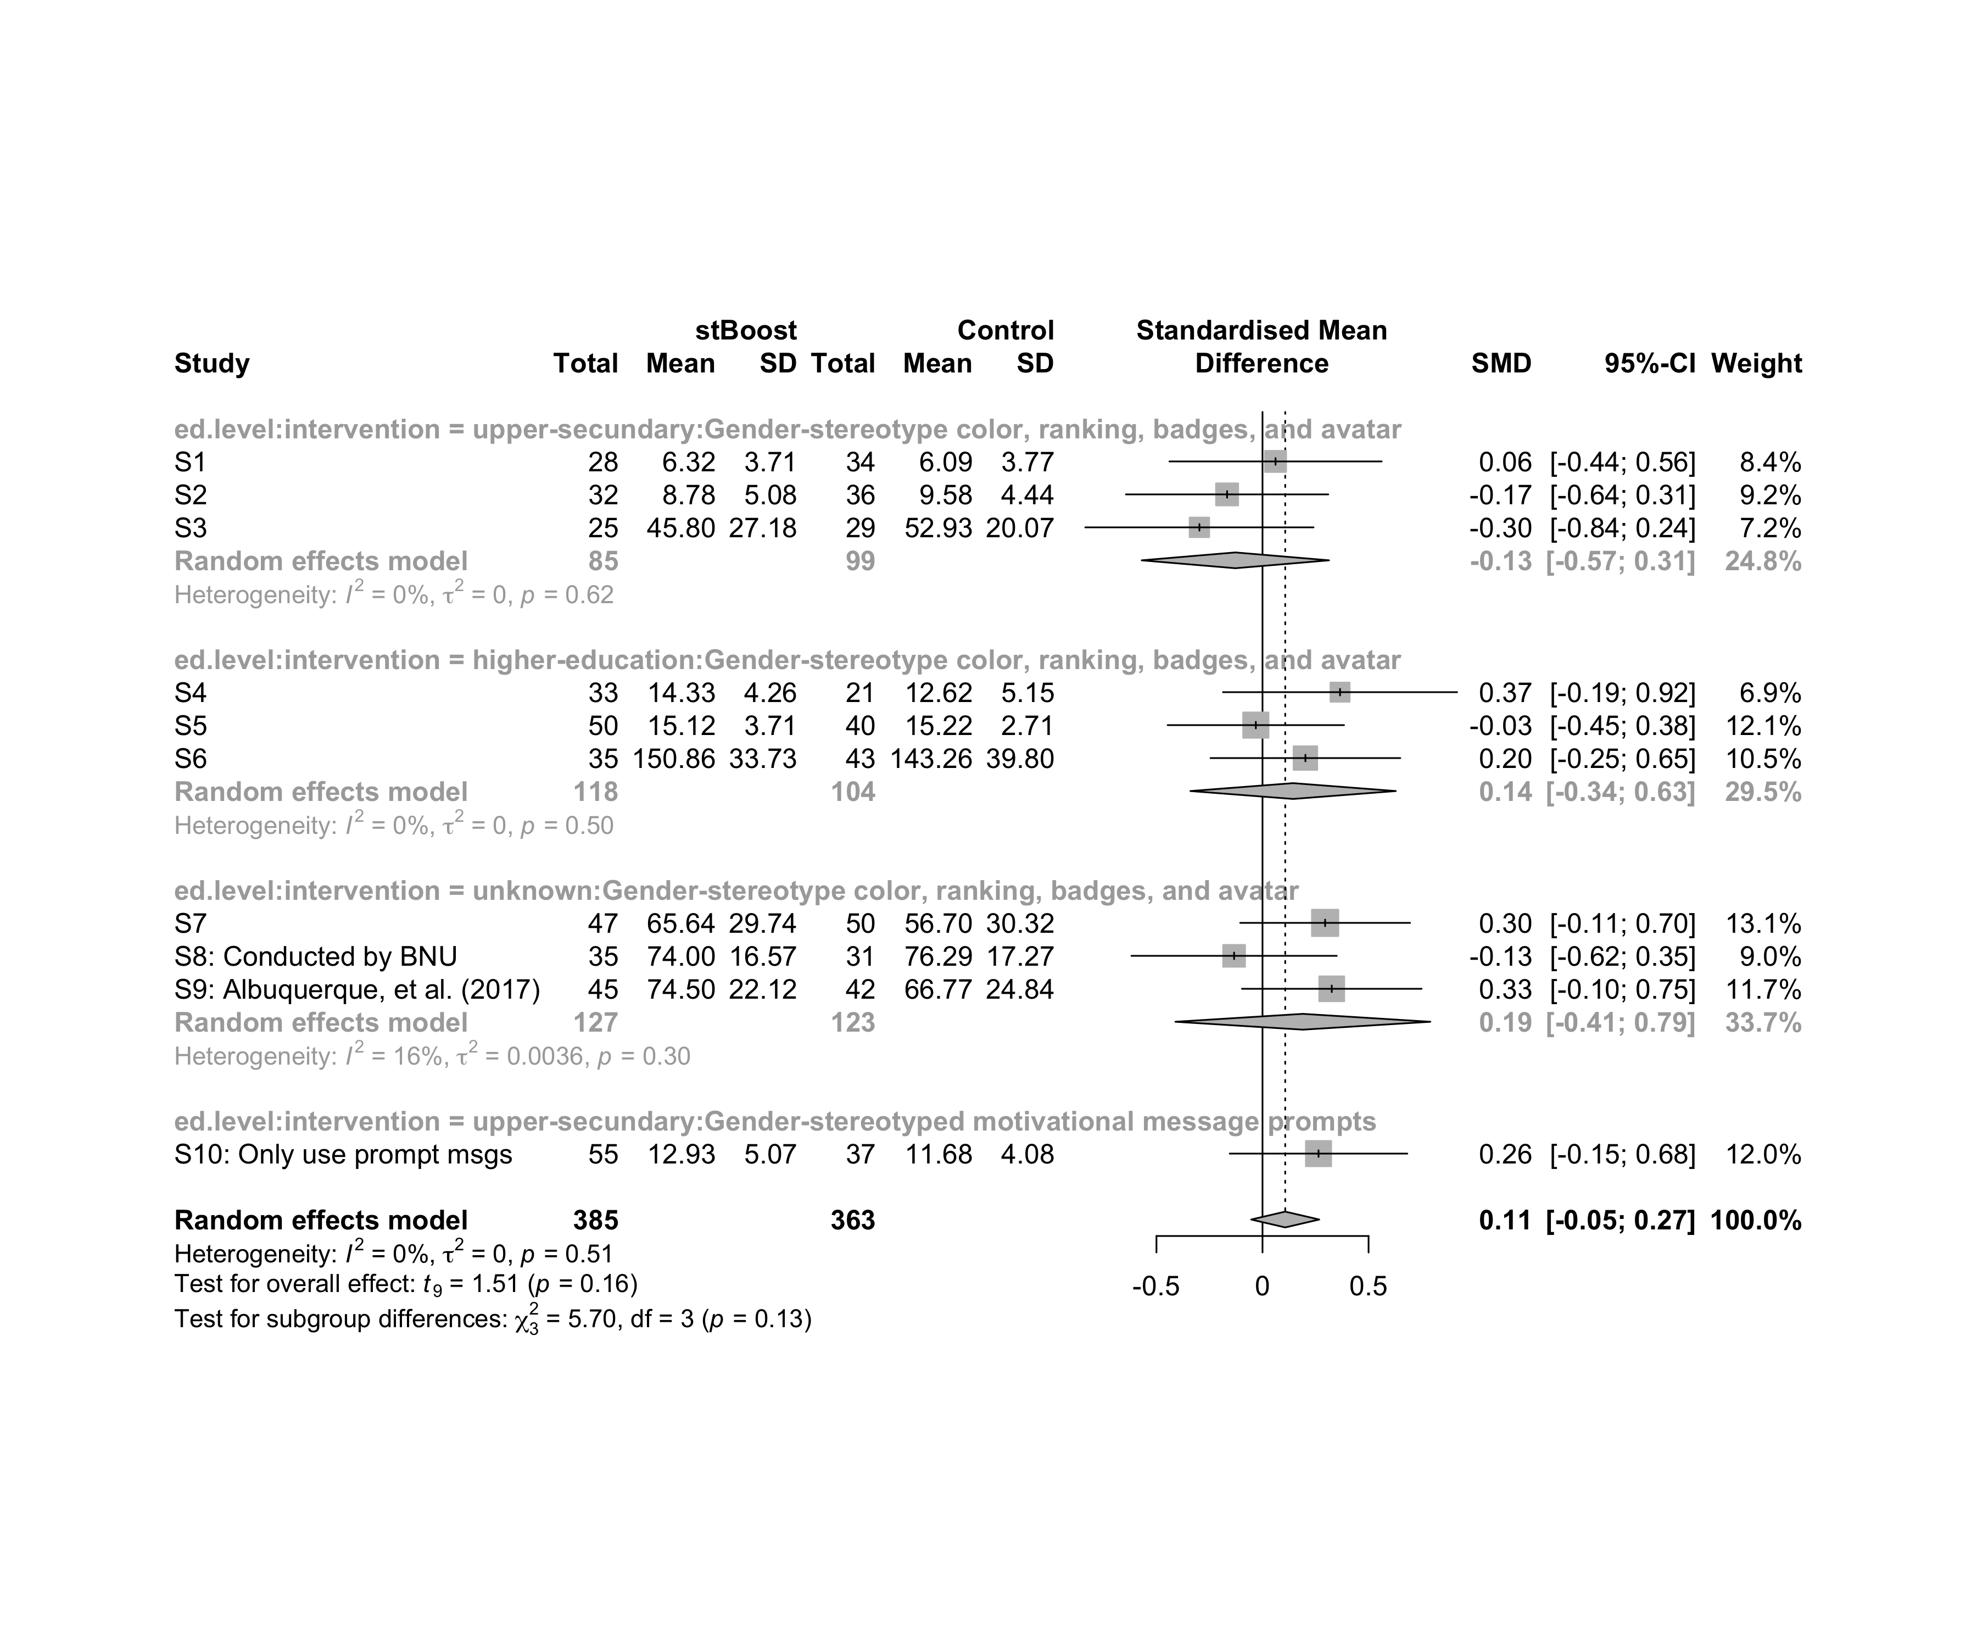

### Subgroup analysis by “country:age:intervention”

m.sg4sub <- update.meta(m.cont, subgroup = `country:age:intervention`, random = T, fixed = F)  
summary(m.sg4sub)

## Review: Performance in stBoost  
##   
## SMD 95%-CI %W(random)  
## S1 0.0615 [-0.4388; 0.5618] 8.4  
## S2 -0.1670 [-0.6440; 0.3101] 9.2  
## S3 -0.2975 [-0.8356; 0.2405] 7.2  
## S4 0.3656 [-0.1862; 0.9173] 6.9  
## S5 -0.0315 [-0.4473; 0.3843] 12.1  
## S6 0.2023 [-0.2451; 0.6496] 10.5  
## S7 0.2952 [-0.1052; 0.6957] 13.1  
## S8: Conducted by BNU -0.1339 [-0.6179; 0.3501] 9.0  
## S9: Albuquerque, et al. (2017) 0.3264 [-0.0970; 0.7498] 11.7  
## S10: Only use prompt msgs 0.2641 [-0.1544; 0.6827] 12.0  
## country:age:intervention  
## S1 Brazil:adolescent:Gender-stereotype color, ranking, badges, and avatar  
## S2 Brazil:adolescent:Gender-stereotype color, ranking, badges, and avatar  
## S3 Brazil:adolescent:Gender-stereotype color, ranking, badges, and avatar  
## S4 Brazil:adult:Gender-stereotype color, ranking, badges, and avatar  
## S5 Brazil:adult:Gender-stereotype color, ranking, badges, and avatar  
## S6 Brazil:adult:Gender-stereotype color, ranking, badges, and avatar  
## S7 Brazil:adult:Gender-stereotype color, ranking, badges, and avatar  
## S8: Conducted by BNU China:no-restriction:Gender-stereotype color, ranking, badges, and avatar  
## S9: Albuquerque, et al. (2017) Brazil:no-restriction:Gender-stereotype color, ranking, badges, and avatar  
## S10: Only use prompt msgs Brazil:adolescence:Gender-stereotyped motivational message prompts  
##   
## Number of studies combined: k = 10  
## Number of observations: o = 748  
##   
## SMD 95%-CI t p-value  
## Random effects model 0.1071 [-0.0532; 0.2675] 1.51 0.1649  
##   
## Quantifying heterogeneity:  
## tau^2 = 0 [0.0000; 0.1227]; tau = 0 [0.0000; 0.3502]  
## I^2 = 0.0% [0.0%; 62.4%]; H = 1.00 [1.00; 1.63]  
##   
## Test of heterogeneity:  
## Q d.f. p-value  
## 8.29 9 0.5055  
##   
## Results for subgroups (random effects model):  
## k SMD 95%-CI tau^2 tau Q  
## country:age:intervention = Brazil:adolescent:Gender-stereo ... 3 -0.1280 [-0.5695; 0.3135] 0 0 0.96  
## country:age:intervention = Brazil:adult:Gender-stereotype ... 4 0.1906 [-0.0844; 0.4656] 0 0 1.75  
## country:age:intervention = China:no-restriction:Gender-ste ... 1 -0.1339 [-0.6179; 0.3501] -- -- 0.00  
## country:age:intervention = Brazil:no-restriction:Gender-st ... 1 0.3264 [-0.0970; 0.7498] -- -- 0.00  
## country:age:intervention = Brazil:adolescence:Gender-stere ... 1 0.2641 [-0.1544; 0.6827] -- -- 0.00  
## I^2  
## country:age:intervention = Brazil:adolescent:Gender-stereo ... 0.0%  
## country:age:intervention = Brazil:adult:Gender-stereotype ... 0.0%  
## country:age:intervention = China:no-restriction:Gender-ste ... --  
## country:age:intervention = Brazil:no-restriction:Gender-st ... --  
## country:age:intervention = Brazil:adolescence:Gender-stere ... --  
##   
## Test for subgroup differences (random effects model):  
## Q d.f. p-value  
## Between groups 8.54 4 0.0737  
##   
## Details on meta-analytical method:  
## - Inverse variance method  
## - Restricted maximum-likelihood estimator for tau^2  
## - Q-profile method for confidence interval of tau^2 and tau  
## - Hartung-Knapp adjustment for random effects model  
## - Hedges' g (bias corrected standardised mean difference; using exact formulae)

forest(m.sg4sub, digits=2, digits.sd = 2, test.overall = T, label.e = cond)

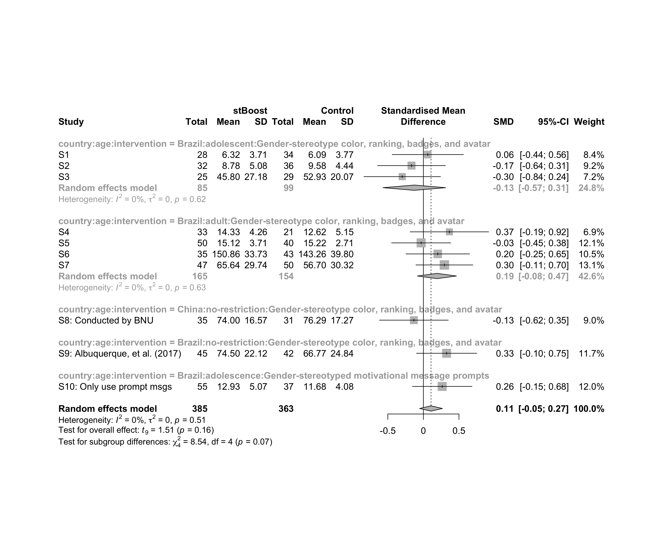

### Subgroup analysis by “country:ed.level:intervention”

m.sg4sub <- update.meta(m.cont, subgroup = `country:ed.level:intervention`, random = T, fixed = F)  
summary(m.sg4sub)

## Review: Performance in stBoost  
##   
## SMD 95%-CI %W(random)  
## S1 0.0615 [-0.4388; 0.5618] 8.4  
## S2 -0.1670 [-0.6440; 0.3101] 9.2  
## S3 -0.2975 [-0.8356; 0.2405] 7.2  
## S4 0.3656 [-0.1862; 0.9173] 6.9  
## S5 -0.0315 [-0.4473; 0.3843] 12.1  
## S6 0.2023 [-0.2451; 0.6496] 10.5  
## S7 0.2952 [-0.1052; 0.6957] 13.1  
## S8: Conducted by BNU -0.1339 [-0.6179; 0.3501] 9.0  
## S9: Albuquerque, et al. (2017) 0.3264 [-0.0970; 0.7498] 11.7  
## S10: Only use prompt msgs 0.2641 [-0.1544; 0.6827] 12.0  
## country:ed.level:intervention  
## S1 Brazil:upper-secundary:Gender-stereotype color, ranking, badges, and avatar  
## S2 Brazil:upper-secundary:Gender-stereotype color, ranking, badges, and avatar  
## S3 Brazil:upper-secundary:Gender-stereotype color, ranking, badges, and avatar  
## S4 Brazil:higher-education:Gender-stereotype color, ranking, badges, and avatar  
## S5 Brazil:higher-education:Gender-stereotype color, ranking, badges, and avatar  
## S6 Brazil:higher-education:Gender-stereotype color, ranking, badges, and avatar  
## S7 Brazil:unknown:Gender-stereotype color, ranking, badges, and avatar  
## S8: Conducted by BNU China:unknown:Gender-stereotype color, ranking, badges, and avatar  
## S9: Albuquerque, et al. (2017) Brazil:unknown:Gender-stereotype color, ranking, badges, and avatar  
## S10: Only use prompt msgs Brazil:upper-secundary:Gender-stereotyped motivational message prompts  
##   
## Number of studies combined: k = 10  
## Number of observations: o = 748  
##   
## SMD 95%-CI t p-value  
## Random effects model 0.1071 [-0.0532; 0.2675] 1.51 0.1649  
##   
## Quantifying heterogeneity:  
## tau^2 = 0 [0.0000; 0.1227]; tau = 0 [0.0000; 0.3502]  
## I^2 = 0.0% [0.0%; 62.4%]; H = 1.00 [1.00; 1.63]  
##   
## Test of heterogeneity:  
## Q d.f. p-value  
## 8.29 9 0.5055  
##   
## Results for subgroups (random effects model):  
## k SMD 95%-CI tau^2 tau  
## country:ed.level:intervention = Brazil:upper-secundary:Gender-s ... 3 -0.1280 [-0.5695; 0.3135] 0 0  
## country:ed.level:intervention = Brazil:higher-education:Gender- ... 3 0.1443 [-0.3400; 0.6285] 0 0  
## country:ed.level:intervention = Brazil:unknown:Gender-stereotyp ... 2 0.3099 [ 0.1119; 0.5080] 0 0  
## country:ed.level:intervention = China:unknown:Gender-stereotype ... 1 -0.1339 [-0.6179; 0.3501] -- --  
## country:ed.level:intervention = Brazil:upper-secundary:Gender-s ... 1 0.2641 [-0.1544; 0.6827] -- --  
## Q I^2  
## country:ed.level:intervention = Brazil:upper-secundary:Gender-s ... 0.96 0.0%  
## country:ed.level:intervention = Brazil:higher-education:Gender- ... 1.37 0.0%  
## country:ed.level:intervention = Brazil:unknown:Gender-stereotyp ... 0.01 0.0%  
## country:ed.level:intervention = China:unknown:Gender-stereotype ... 0.00 --  
## country:ed.level:intervention = Brazil:upper-secundary:Gender-s ... 0.00 --  
##   
## Test for subgroup differences (random effects model):  
## Q d.f. p-value  
## Between groups 22.75 4 0.0001  
##   
## Details on meta-analytical method:  
## - Inverse variance method  
## - Restricted maximum-likelihood estimator for tau^2  
## - Q-profile method for confidence interval of tau^2 and tau  
## - Hartung-Knapp adjustment for random effects model  
## - Hedges' g (bias corrected standardised mean difference; using exact formulae)

forest(m.sg4sub, digits=2, digits.sd = 2, test.overall = T, label.e = cond)

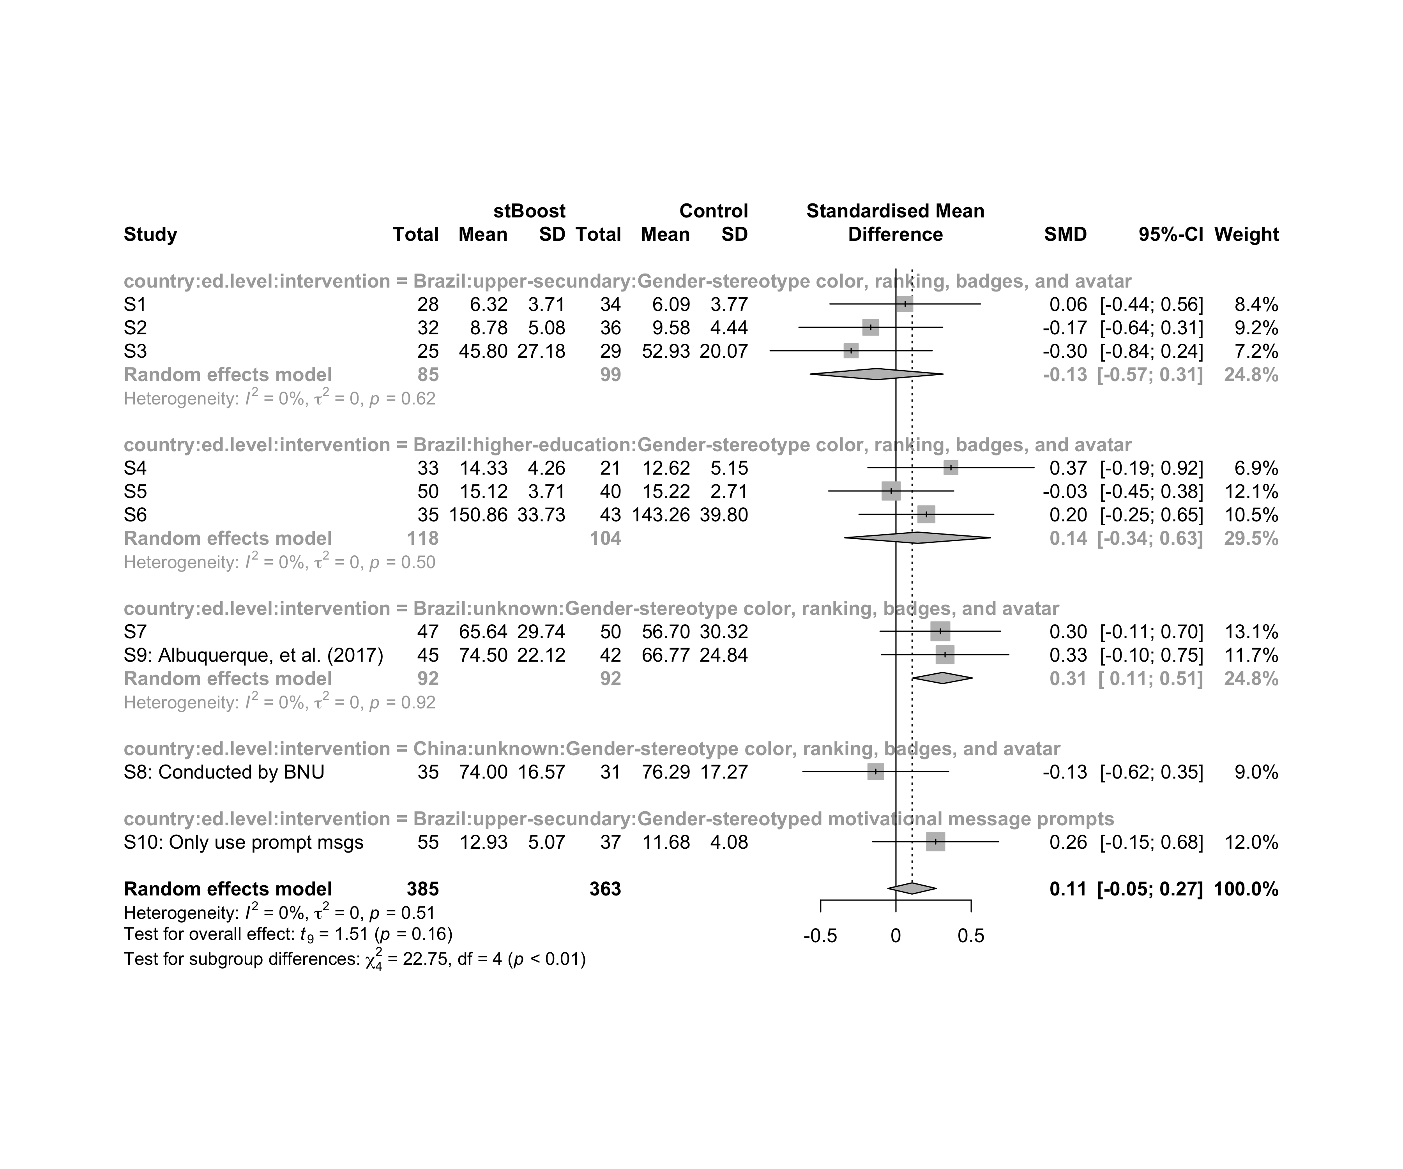

## Funnel Plot

m.cont <- update.meta(m.cont, studlab = data$study)  
summary(eggers.test(x = m.cont))

## Eggers' test of the intercept   
## =============================   
##   
## intercept 95% CI t p  
## -3.692 -9.15 - 1.77 -1.325 0.22  
##   
## Eggers' test does not indicate the presence of funnel plot asymmetry.

funnel(m.cont, xlab = "Hedges' g", studlab = T, legend=T, addtau2 = T)

